Games Design Document

Arcane Annihilation

Contents
High Concept 4
Overview 4
Game Loops 4
Game Pillars 4
Environment 4
Genre 4
Game Mechanics 4
Movement 5
Weapons 5
AI 6
Random Weapon Chest 7
USP 7
Player Characteristics Outline 7
Target Audience 7
Level Design Documentation: 8
Goals of level & key areas 9
Key Features of level: 9
Story 9
Visual Development 10
Colour Palette 11
Level Design Plan: 12
Player Characters, Controls and Abilities 15
Player Controls and Map 16
Player Camera 16
Weapons and Pickups 17
Ammo Description 17
Game Conditions 19
How do you win? 19
How do you lose? 19
Can you die? 19
Rewards and Progress 20
Score such as multipliers, kills, kill count, collection based. 21
UI Design 21
In Game 22
Menu 23
Enemy Design 23
Enemy Theme 24
Enemy Loop 24
Enemy Characteristics 24
Stats 24
Level Elements 24
MoSCoW 25
Sound List 26
Character Sounds 27
Environment Sounds 27
Object Sounds 27
Animation List 27

High Concept

Overview
Fast paced, magical and mobile. Traverse the arena and fight off swarms of enemies for as long as possible. Use different magical guns to eliminate enemies, use the environment to keep up your momentum and stay untouchable.

Game Loops
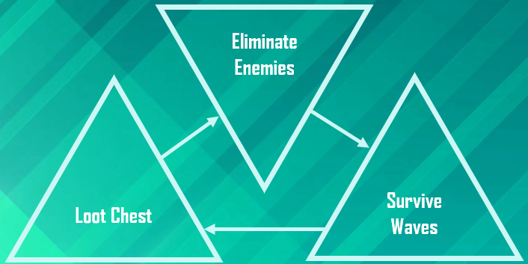

Game Pillars
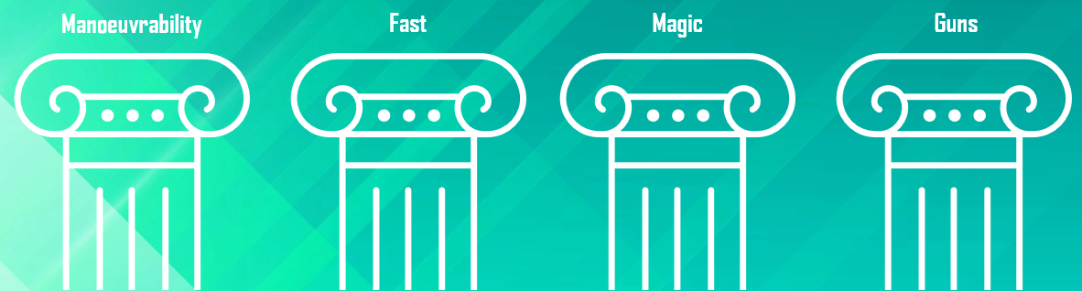

Environment
This outdoor space will need plenty of walls and platforms for the player to use to their advantage. Ideally, a natural looking environment man-made structures that fit the magical, off world theme.
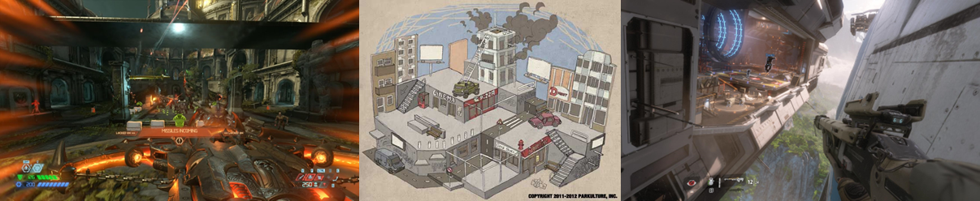

Genre
FPS, Action, Fantasy

Game Mechanics

Movement
The player’s gameplay experience should be ‘face paced’ and ‘high velocity’, therefore player movement needs to reflect that by keeping a fast-paced movement system. The player will be able to use different movement abilities to traverses around the level and help during combat, these include:
- Wall Run
- Slide (Power slide)
- Jump (high depending on time held)
The key to having a good movement system for the game will be having the system to flow and keep gameplay action high.

Weapons
Weapons for the game will be somewhat randomised but fundamentally simple too. The player will be able to hold 2 weapons at a time and switch between them at any point.
To keep the player momentum high, the weapons won’t feature an ADS system (aim down sight) and instead, the weapons will be purely fired from hip point using a crosshair on screen. In addition, keeping up the player momentum, weapons won’t feature an ammo count that will deplete the weapon completely, instead the weapon will use a ‘soft count of ammo’ that when ammo hits 0, will do a reload animation (Much like in Overwatch).
There will be 4 base weapons in the game the player can acquire. Each ‘base’ weapon has its own unique controls including Base damage, Fire Rate and if its Automatic.
4 Base weapons are:
- Shotgun
- Assault Rife
- Rocket Launcher/Grenade Launcher
- Singe fire Rife

Each base weapon has different components that change both the look and gameplay of the weapon.
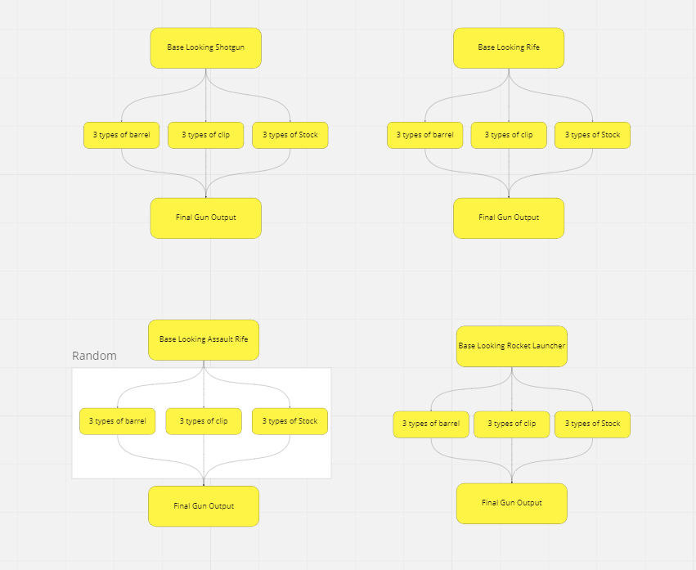
The 3 types of components are:
- Barrel – Controls, Range, Fire Point Location and Projectile Colour
- Clip – Magazine Size, Damage Multiplier and Reload time.
- Stock – Mobility, Accuracy and Recoil amount
Upon receiving a weapon, the player is given a random assortment of each type of component that then makes the weapon overall.

AI
AI will be present through the arenas of the game. Initially there will be 2 types of AI:
- Swarmer type
  - Spawns in large numbers
  - Has low health
  - Goal of surrounding the player to deal damage.
    - Can either melee or explode upon reaching player.
  - Explode damage is high, whilst melee damage is low.
- Sniper type
  - Sits further back shooting the player.
  - Deals moderate damage whist having moderate health.
  - An enemy the player will want to prioritise over swarmer AI.
Each area will have waves of enemies that progressively get harder has rounds go on, with the idea of the game going infinite (or to a high round). The AI goal will be to kill the player to end the game. The player can heal off the AI by killing them in melee of proximity.

- Waves of enemies with increase in difficulty
- A loot crate will spawn between rounds with weapons to choose from
- Enemies will try to slow you down, making you vulnerable.
- Use your melee weapon to heal.
- Cartoon style visuals, UI and effects

Random Weapon Chest
The random weapon chest is an interactable object that the player uses to get a new weapon and progress the game. The idea behind it is that the player will force swap weapons in order to progress the game.
The chest can only be used once per round to get a new weapon, and it’ll swap out for your current one equipped.
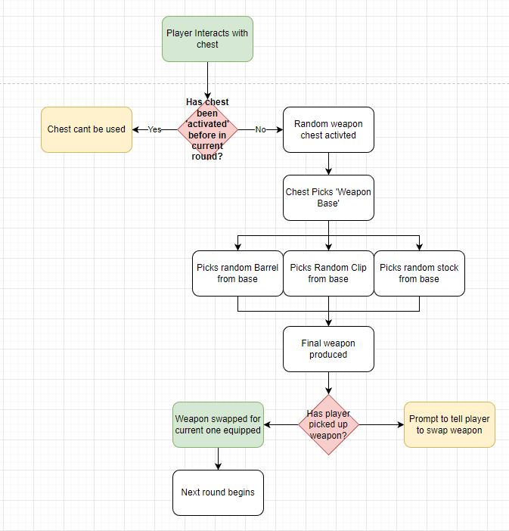

USP
Unique weapons, In depth movement system

Player Characteristics Outline

Soldier based human who has travelled off world, where gravity is not as strong as Earth. Wearing a highly advanced exo/space suit. The game is in first person, so you will only see the arms, hands and guns.

Target Audience
Anyone who enjoys action, magic and a fast-paced environment. Expected to interest older teenagers and adults.

Level Design Documentation:

Goals of level & key areas

Key Features of level:
Wall Run – with one of the key movement mechanics of the player movement, wall running across the level will be very important. When building out the level during meshing and blockout, having areas where the player can wall run to either traverse around the map or shooting during combat will be important.
Momentum – We can keep player momentum high and so having lots of open areas for the player to move and not stop, also having less obstacles in the way around the map to not stop the player.
Crouch and Slider – small areas where the player can power slide either around the map or under objects to get to areas of other parts.
USP of the map – Using monuments so the player isn’t lost in the map. Centre bridge, so the player can find the chest easy enough, high points so the player can look over the map to find where to go.

Areas:
Key areas of the map include:
Pink – Castle area, ruined run-down castle.
Blue – Cliff area with highest level of elevation
The rest of the map will be a forest area where the player could become bogged down in enemies via trees and rubble.

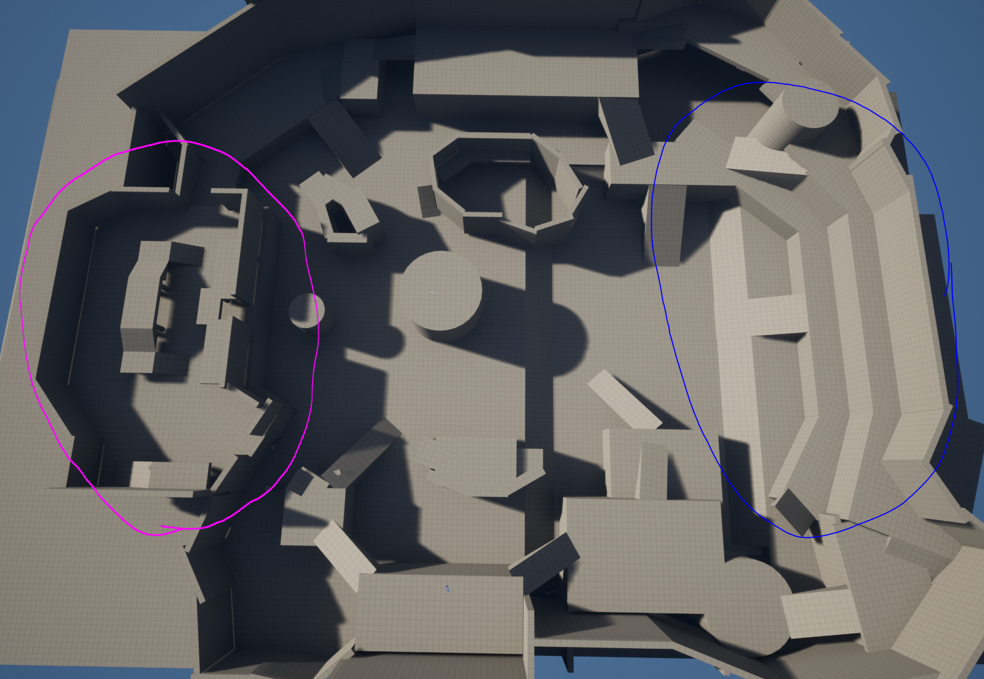

Survive as long as possible.

Story
You’ve gone exploring, but you have encountered a dangerous threat that wants you dead. You cannot escape, your only hope is to take as many of the enemies with you.

Visual Development

Colour Palette
Environment
Any Blue will represent magic in the world.
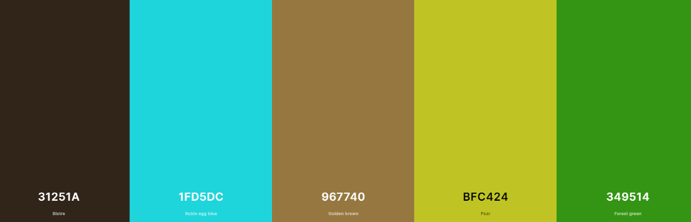
Lighting

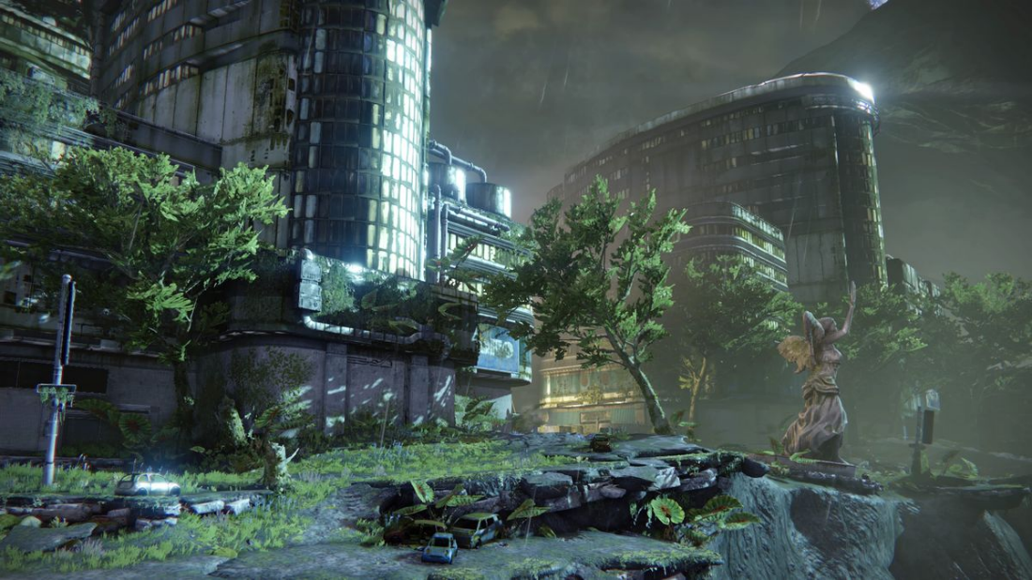
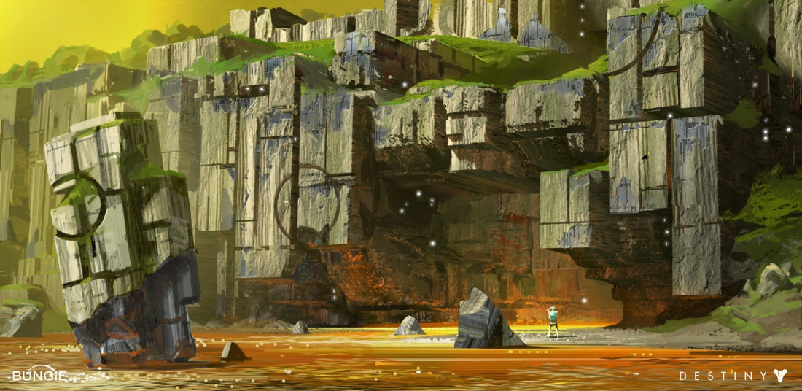
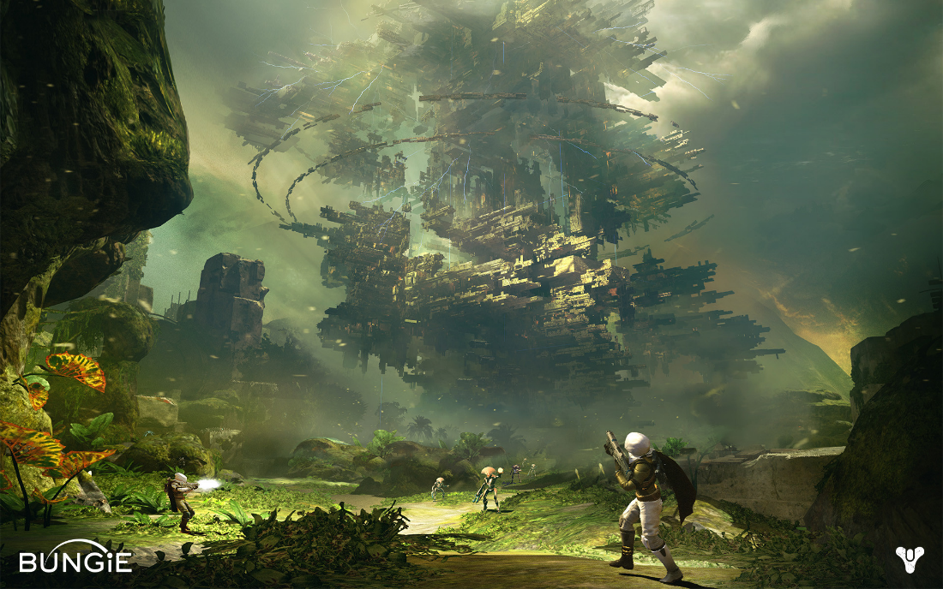

Level Design Plan:
- Green Circle – Health Pickup
- Blue Circle – Chest
- Purple Circle – Player Start

Main Game map:
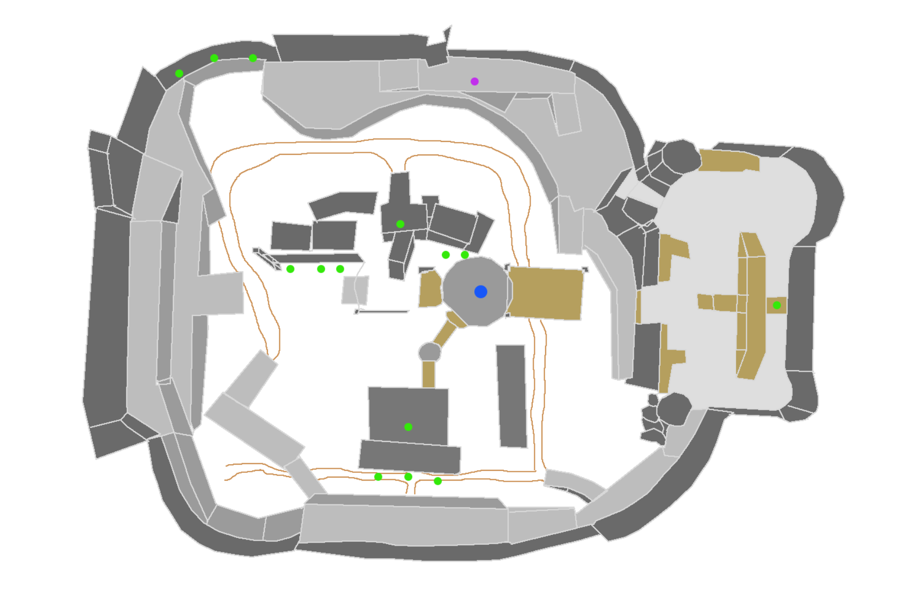
Figure 1 - Map overview

Wall Run Areas

The black lines along most of the sides indicate where the player can wall run in the level. Whilst the player can wall run along most surfaces, there area some areas that will be more highlighted as an ‘ideally’ place for the player to wall run across. To accommodate for the wall run, most areas should be round and flat with minimal bumps as to not stop player from mid wall running.
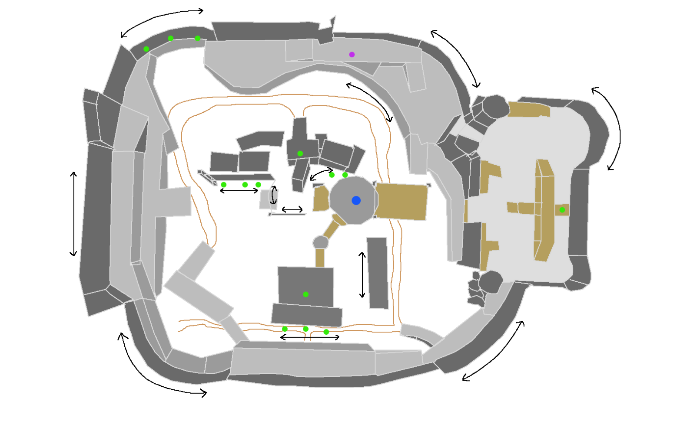
Figure 2 - Wall Run Areas

Action Areas

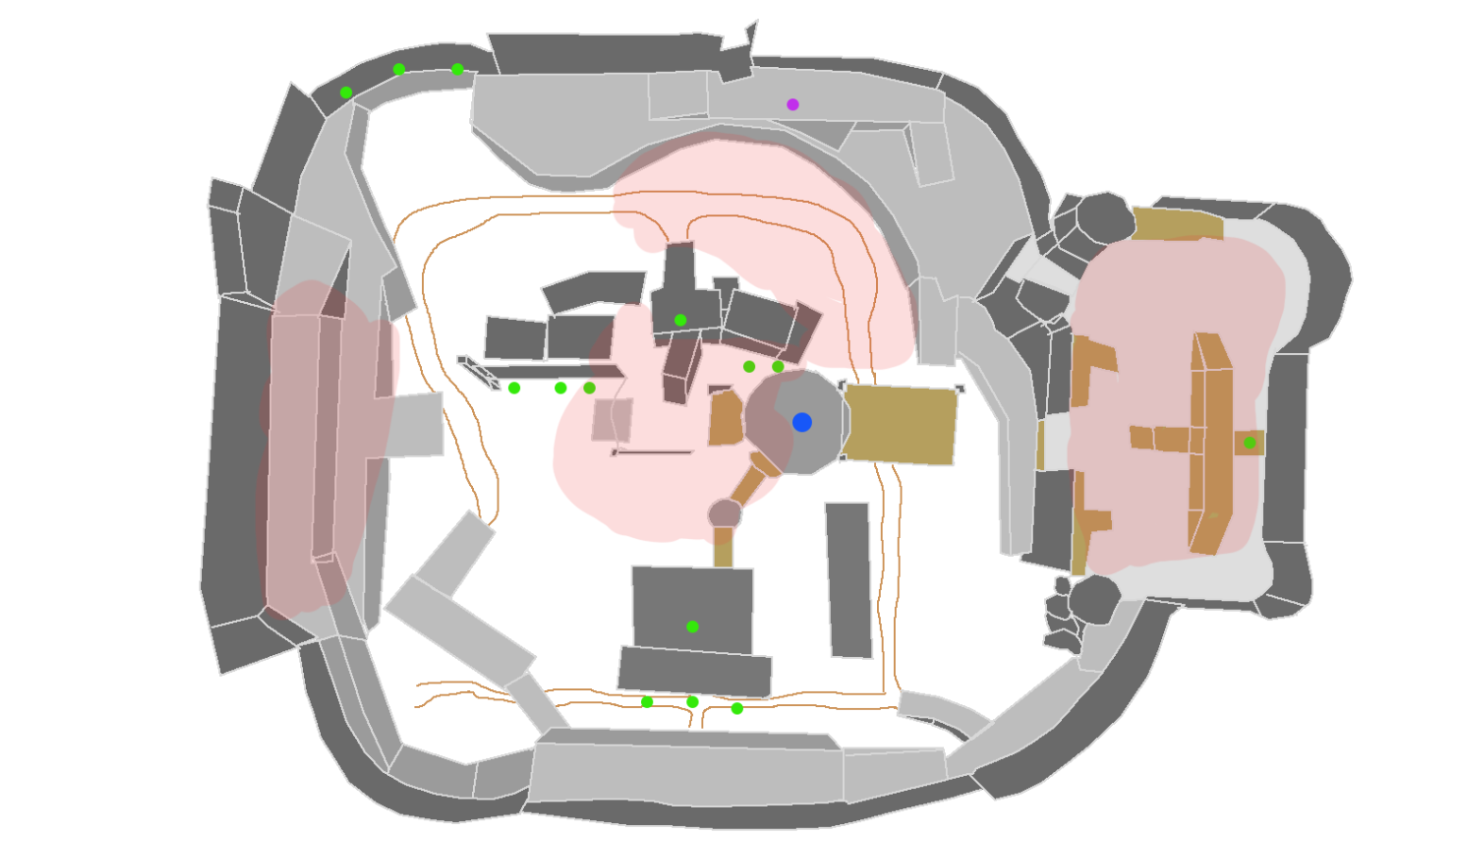
Figure 3 - Action Zones
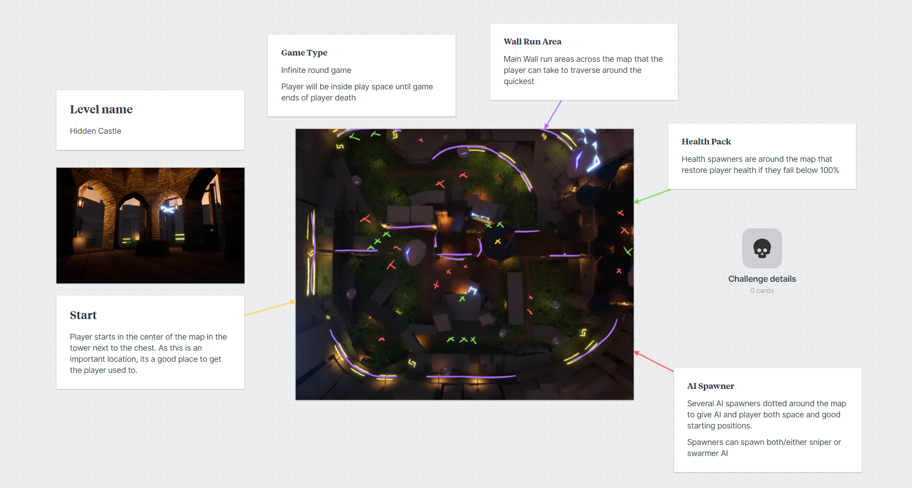
Figure 4 - Level Plan with updated images

Player Characters, Controls and Abilities

Player Controls and Map

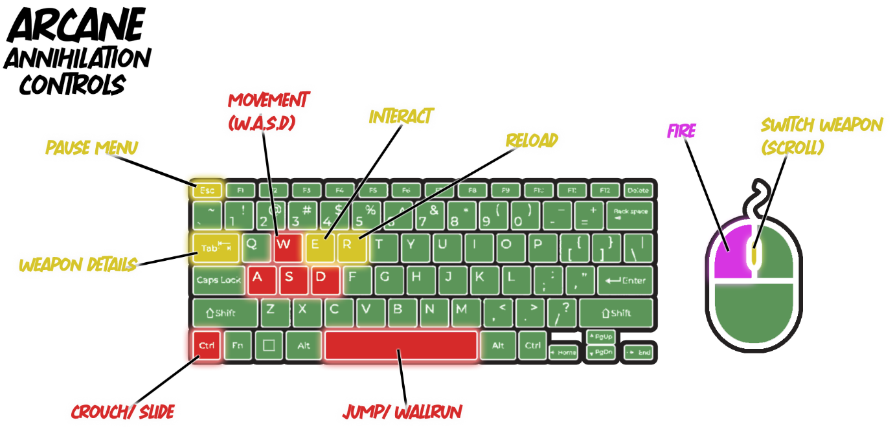
Figure 5 - Control Map

Player Camera
First Person perspective

Character/s Mechanics
- Jump
- Slide
- Pick up guns.
- Switch Weapons
- Health
- Wall run sideways.
- Gain momentum

Weapons and Pickups

Weapon Description
Weapons will be randomized from a series of attachments to make a gun that will have a random fire type. The barrel, stock, ammo clip, sight and base of the weapon will all have as many variations as possible that can be mixed and matched together to make it look like there are more guns than there are.

Ammo Description
The weapons will have infinite ammo, but they will have a clip size. So, the only thing slowing the player down will be reloading the weapons.

Game Conditions

How do you win?
Surviving for as long as you can. This mean beating the wave without dying and looting a new weapon at the end of the round. As the game is infinite, the longer u survive == the ‘better’.

How do you lose?
You die without being able to beat your previous high round score.

Can you die?
Yes, dying ends the game. The player dies upon reaching 0 health in the game.

Rewards and Progress
Round Start
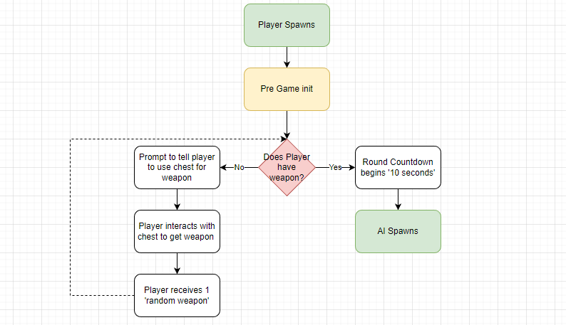
Round End/AI Killed
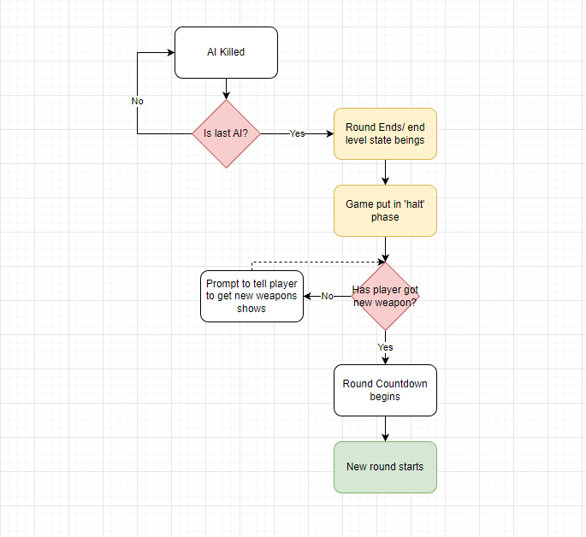

The game is infinite with the number of rounds going up 1 at a time. Round progression is gained after the player has eliminated all the enemies on the level that have spawned. After this the level is over and the player is placed in a pre-game phase where they must use the chest to get a new weapon.

If the player dies, the round limit is counted, and an overall score is given based off rounds survived and possibly score from killing/damage.

Score such as multipliers, kills, kill count, collection based.

UI Design

In Game
Needs:
- Player aim reticule
- Weapon stat box
- Ammo and health stats
- Round counter
- AI counter
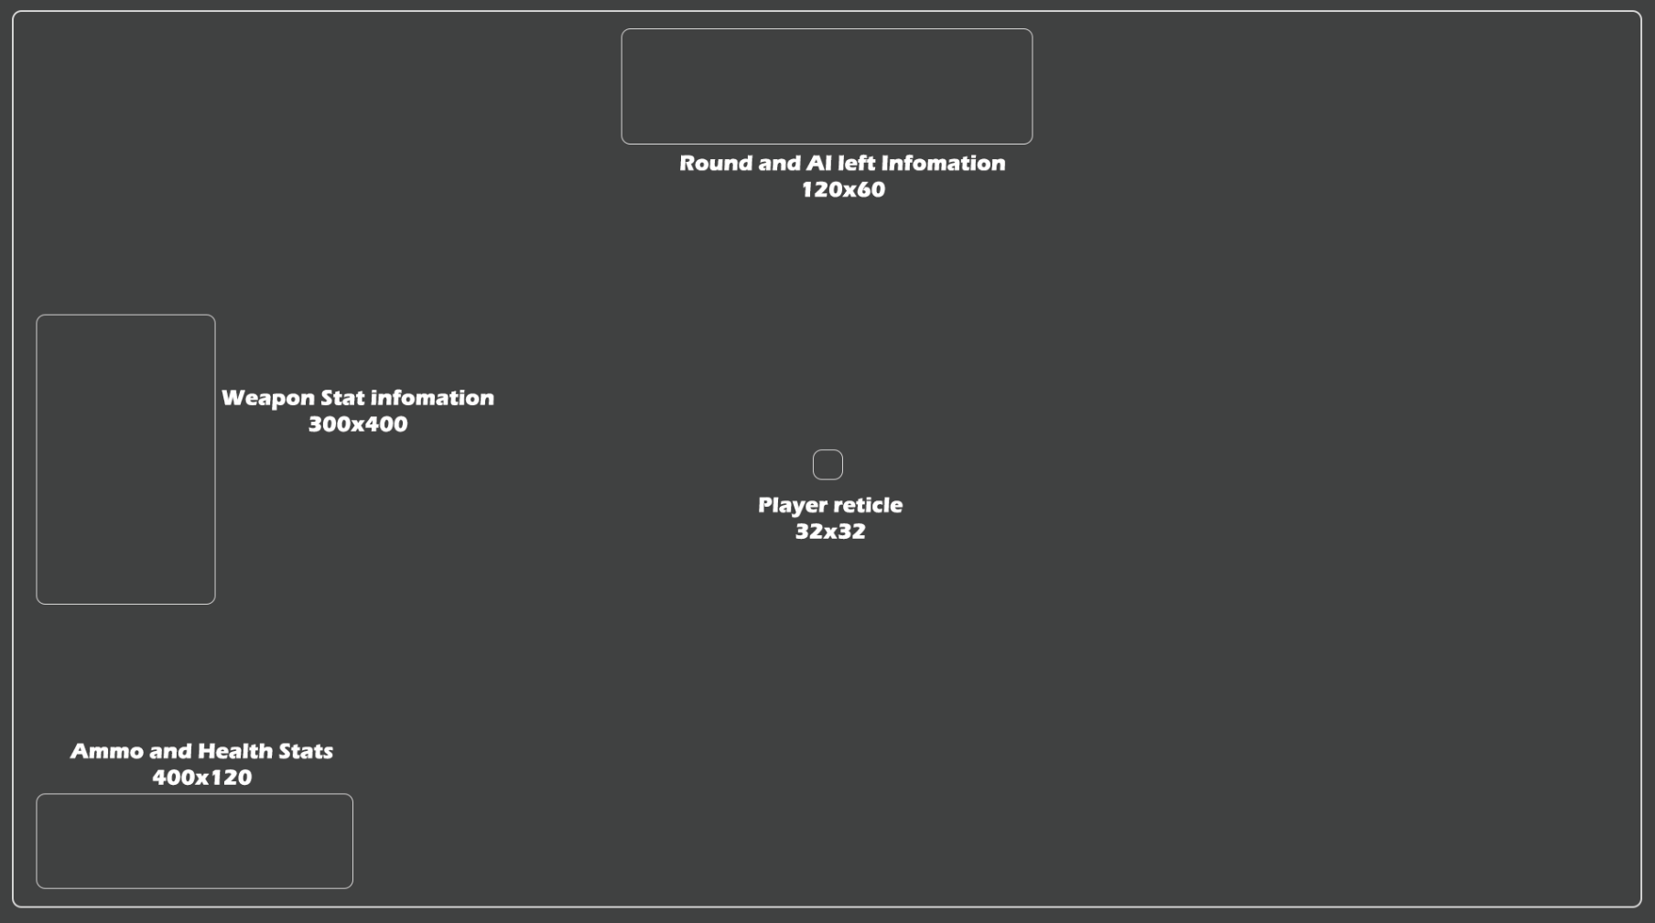

Menu

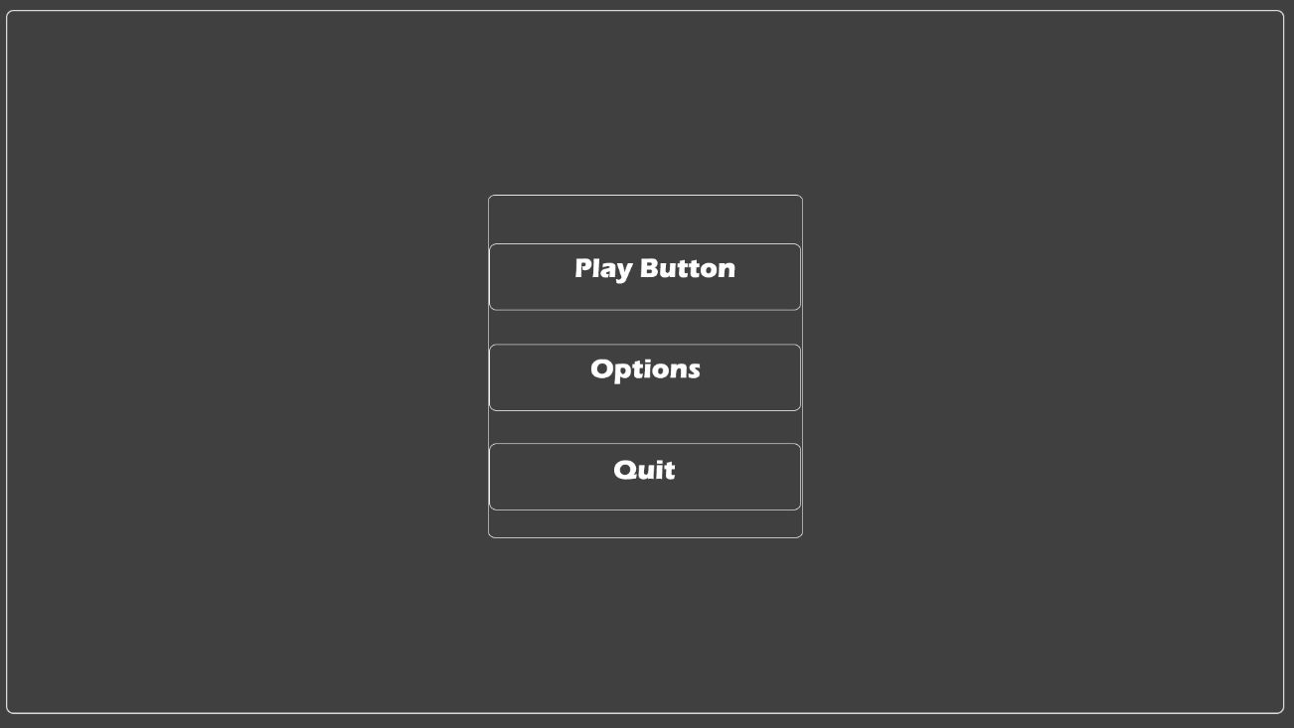
Main player menu needs:
- Play Button
- Options
  - Sounds Menu/sliders.
  - Control Map
- Quit
Same overall menu can also be used as a pause menu for in game.

Enemy Design

Enemy Theme
- Cartoony skeleton to fit in the theme of our game.
- 2 types of AI and so two different looking models are needed.
- The sniper AI should be taller and stand out more compared to the normal swarmer AI

Enemy Loop
- Find player.
- Attack player
- Roam

Enemy Characteristics
- Swarmer AI
  - Designed to chase player around the map in large number.
  - Less health the regular but have greater number.
  - Goal is it surround player and ‘mob’ player.
  - Weak but strong in number
- Sniper AI
  - Has more health
  - Sit further back and snipe’s player with a ranged attack.
  - Has more health than swarmer but less numbers of them
  - Attack does moderate damage.

Stats
Type | Health
Swarmer | 20
Sniper | 80

Level Elements
Levels spawn a random number of AI through data assets set up prior to build and so play testing to get a good number of them will need to be looked at. As the round go on, the game will get harder and so harder, and more AI will spawn as the game continues.

MoSCoW
Must
- Player movement
  - Sliding
  - Wall Run
  - Jump
  - Weapon Recoil
  - Fast Paced
- At least 2, designed weapon types:
  - Shotgun
  - Machine Gun
  - Assault Rifle (single fire)
  - Grenade/rocket launcher
- At least 2 AI types:
  - Swarmer enemy – (explode/melee as combat)
  - Sniper type enemy – (Stands from far, range combat dealing moderate damage).
- Random Weapon designer:
  - Each weapon type has at different combination of attachments to choose between (Barrel, stock and clip).
- 1 polished and designed arena ‘level’.
  - Utilizes player movement features to ‘feel good’ moving around level.
- Tutorial/ playground level for player to learn game.
- Round based system.
  - AI spawn in rounds with progressive difficulty
  - Once player finishes round, player goes into a (pregame hold).
- Random weapon chest that spawns new weapon for player at round end
- Menu elements
  - Main menu
  - Options
  - Exit
  - Pause Menu with above.
- Player UI
  - Health
  - Ammo count
  - Damage Numbers
  - AI left?
- Game Loop
  - Run and gun - Kill - Loot

Should
- Additional Weapon
  - 2 more weapons that are designed and implemented.
  - Each weapons have their random assortment of attachments.
- Another well designed and polished arena level
- Player Game Juice
  - Camera Shake
  - Particle Effects (wind throw camera)
- Weapons game juice
  - Camera shake
  - Particle Effects
- Sounds
  - Weapons sounds
  - Player sounds
  - Environment sounds
  - Game Music
- Score system
  - Either works from player score and/or damage dealt to enemy
Could
- Another enemy type
  - Boss
  - Brute enemy that has high health and knock back.
  - Turrets
- Traps
Won’t
- Multiplayer
- Story
- Linear levels

Sound List

Character Sounds
- Walking/ movement sounds
- Jumping sound
- Wall Run sound.
- Swap Weapon sound

Environment Sounds
- Intense game background music
- Ambient noise for in between rounds.

Object Sounds
- Gun sounds
  - Firing
  - Reloading
- AI death sounds
- AI hitting sounds.
- Chest sound
- UI button sounds.

Animation List
Ai animations for:
- Idle
- Death
- Attacking
- Walking
Ideally have a couple of different ones to cycle though to give the animation more depth and variety during games.

