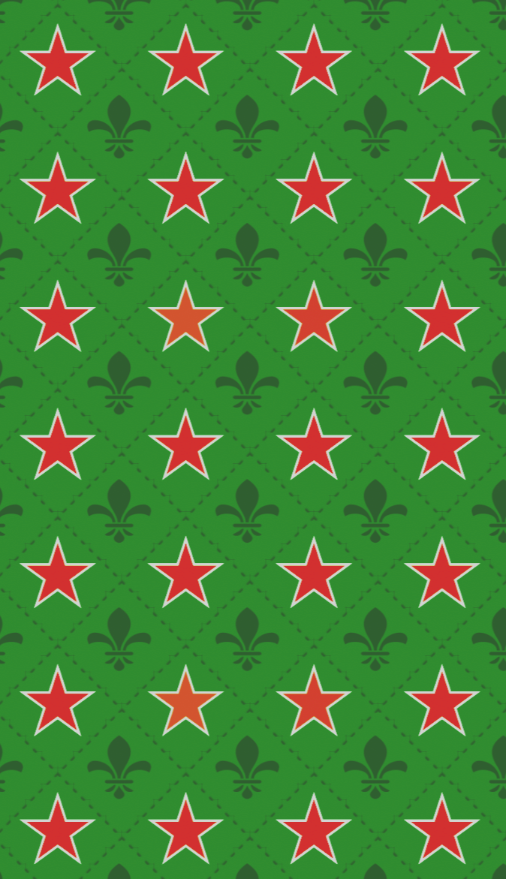

Games Design Document

Heine Pub

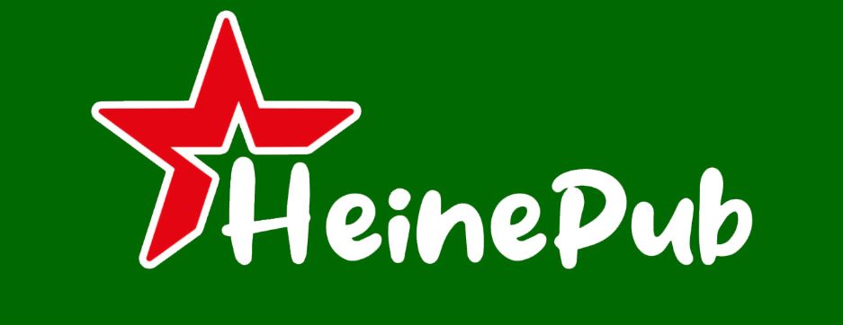

Contents
Games Design Document 1
Overcook Game 1
High Concept 4
One line Introduction 4
Game Loop 4
Theme/Environment/Setting 4
USP and Mechanics 4
Making Drink Mechanic: 4
Serving the drinks: 5
Mini Games: 5
Hazards: 6
Bar Fights 6
Order System 8
Cocktail System 10
Game Pillars 11
Pickups 12
MoSCoW 12
Must 12
Should 12
Could 13
Would 13
Level Design Plans 13
Level Rules 13
Level Plans 13
Maps 13
Tutorial Level 15
After Hours Level 15
Wheel Level 15
Player Character, Controls and Abilities 16
Control Maps 16
Level Camera(s) 16
Character Mechanics 16
Character Physics 17
Character Stats 17
UI 17
Ui Needs 17
UI Wireframes 18
UI Sounds and Text 20
Text Styles 20
Sounds 20
Game Conditions 21
How do you win? 21
How do you lose? 21
Reward and Progression 22
Game Progression 22
Player Goals 23
End Achievements 24

High Concept

One line Introduction
An Overcooked styled game set in a bar where the players go is to serve drink in a set time for rewards.

Game Loop
Make Drinks - Serve Drinks - Get Money
The player will receive and order from the customer. The player’s goal is to now, complete the order and send it back to the customer for cash.
The overall goal of our game will be to make as much money has you can before going ‘bust’ (failing). The player will have to take orders, complete order, and move on to collect money and progress.
The more money brought in == higher end score.

Theme/Environment/Setting
Set in a British pub/bar.
Low poly/stylized look.

USP and Mechanics

Making Drink Mechanic:
  - When the player has an order for a drink come in, it is up to the player to begin that order. The order can come in different ways (more/less foam on beer).
  - The player will have to move to the tap and interact to start filling up the tap.
    - Players will have a choice of different drinks to pick between
      - Cider
      - Heineken
      - Shandy
      - Guinness
    - After picking, the pour begins
  - While the player is filling up the glass, the player must keep an eye on the current state at which the drink is at in order to meet the correct state the order requires.
    - The player can complete the order 1 of 3 ways:
      - A bad Pour – Brings in less money, can cause spillage and increase bar fight progress bar.
      - A good Pour – Gets Normal tip with no good or bag modifiers.
      - A Perfect Pour – Gets more money with a reduce to the bar fight progress bar.
    - The player must stop interacting with the station for the drink to stop filling.
  - The player must press a button to initiate the pour.
  - A UI with a moving arrow on a bar/semi-circle containing bands of colours red, blue and green which correspond to bad, good and perfect pours with randomized speeds for each pour (to eliminate good players from relying on muscle memory) will be displayed for the player to click on.
  - The player will be rewarded according to the area of the bar/semi-circle their arrow lands upon after pressing the said button.
  - Once filled, the player will go to the order station (or AI) to give it the order can move on. This is the repeated for the game loop.

Serving the drinks:
  - When the order has been taken, it begins a timer that counts down for the player to complete the order.
  - player has left on the timer impacts the player’s reward/tip.
    - A faster time will result in a bigger tip.
    - A slower time will result in a smaller tip.
  - Failure to make an order on time will result in 2 penalties:
    - The bar fight meter will increase drastically.
    - The player will receive 1 strike. 3 of these and the game is over.

Mini Games:
  - During the game, challenges will pop up during play around the bar that the player will have to deal with.
  - These challenges will vary in impact, but they are tasking the player will have to do to have an easier time during gameplay.
    - Changing Barrel
    - Spillage appearing on floor (slowing down player)
  - Challenges are dealt with easily (by interacting on them) and after a short time are cleared.
  - The mini games are designed to get in the players way as an interference/annoyance.

- Barrel filling – player must refill barrels from when the main source is nearly empty to avoid hindering with the flow of orders and receiving penalties.
    - There are a total of 4 barrels.
    - One barrels can pour 5 pints.
    - Once the barrel hits a minimum of 1 pint the player must go and refill the barrel.
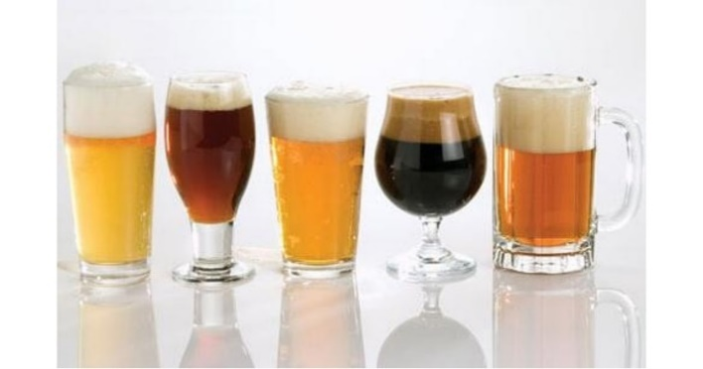
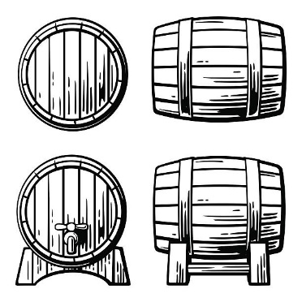
Figure 1 - barrel pour amount
Figure 2 - Barrel Concept

Hazards:
  - Spillage – pouring bad pints results in spillage and affects the players speed and quality of work.
    - Pouring 1 bad pint == Dirty table
    - 2 bad pints == spillage
    - More than 2 == slippery floors
  - Slippery floors – slippery floors need cleaning which will consume a certain amount of time and coins, resulting in reduced order processing.
  - Faulty equipment – broken glasses and non-working equipment need coins for fixing.
  - Penalty – Failing to fix any of the above-mentioned hazards on time leads in a penalty to be paid.

- Upgrades – Player can upgrade their speed and size of orders.

Bar Fights
  - Bar fights occur when the progress bar of the event reaches its max. (100)
    - The progress bar is instigated by:
      - Players not fulfilling an order. (+20)
      - By pouring a bad drink, angering the customer. (+10)
  - This causes a bar fight to happen, causing havoc for the player as they must bring an end to it.
  - The only way a bar fight can be stopped is by the player calling in the bouncer. This ends the fight but costs the player cash.
    - Upon a fight being ended, the progress bar is reset back to 0 and the cycle continues).
  - Each time a bar fight happens, the cost of calling in the bouncer increases.
  - Player penalty for bar fight
For the first time, the player is charged 1 coin, 1.5 coins for the second time, 3 coins for the third time and so on, i.e., an addition on 1.5 coins every other bar fight.
Or
1 coin for the first time, 1.5 for the second time, 2.25 coins for the third time and so on, i.e., a multiplication of 1.5 coins every other bar fight.
  - During a bar fight, orders will continue to come in and so the player must balance out dealing with the fight whilst making orders.
  - If the fight isn’t stopped in time, the game is ended, and total score is added up.

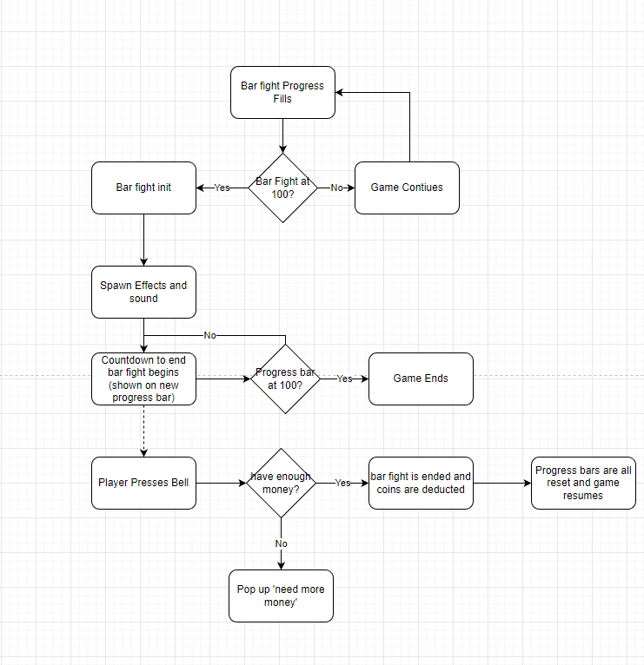
Figure 3 - Bar Fight Flowchart Layout

Order System
The order system is the main mechanic that drives the player to pour pints and progress. Orders will come in at the start of the game at steady rate and gradually increase as the game progresses.

  - At the start of the game, orders are initialized on a curve.
  - The order will spawn and can be one of two (pint or cocktail). This is done at random.
  - The order is then placed on a widget at the top right of the screen and keeps adding up until it leaves the screen on the left.
  - The order card will spawn along with a progress bar on it that will slowly tick down. (20 seconds).
  - The player will then be alerted that they must complete the order shown within the given time frame.
  - The player must analyse and check the pint or cocktail that has been ordered and deliver it to the customer/service area.
  - An order card disappears once the order is completed.
  - If an order leaves the screen on the left without being completed the order card is deleted and the player receives feedback (flash or red background UI) and a penalty (bar fight, negative reputation etc.).
    - Orders will at the start pouring a simple beer. (This will then be designed upon overtime).
  - Upon serving the pint, the order is completed, and the order card is removed from the screen.
Orders can pile up and build up overtime if the player fails to serve or deliver the correct order. Failing to serve an order will result in a ‘+1 negative review’, failing to do this 10 times will result in a failure (see coin and pint progression for further detail) and the game will end.
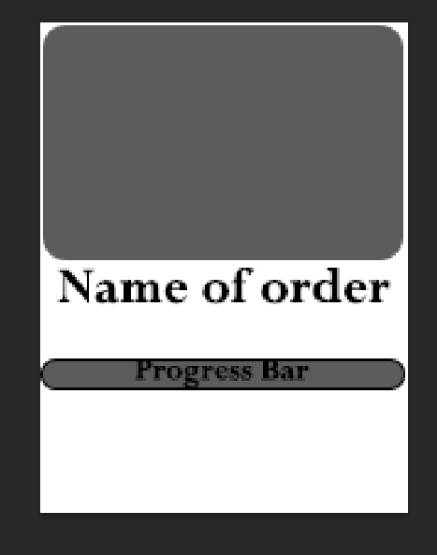
Figure 4 - Order Card Concept
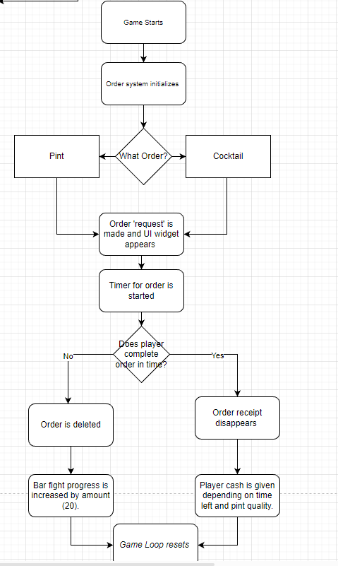
Figure 5 - Pour Pint System Flowchart

Cocktail System
The cocktail mechanics will be the second system for the player to interact with alongside pouring beers. The mechanic works by combining two items to make a single item which will be used to order. Ideally there should be 3 of each mixture stored for the order that UE chooses between, this could include:
juices
- Pineapple Juice
- Cranberry Juice
- Orange Juice
Spirits
- Vodka
- Rum
- Gin
- Whisky
- Tequila
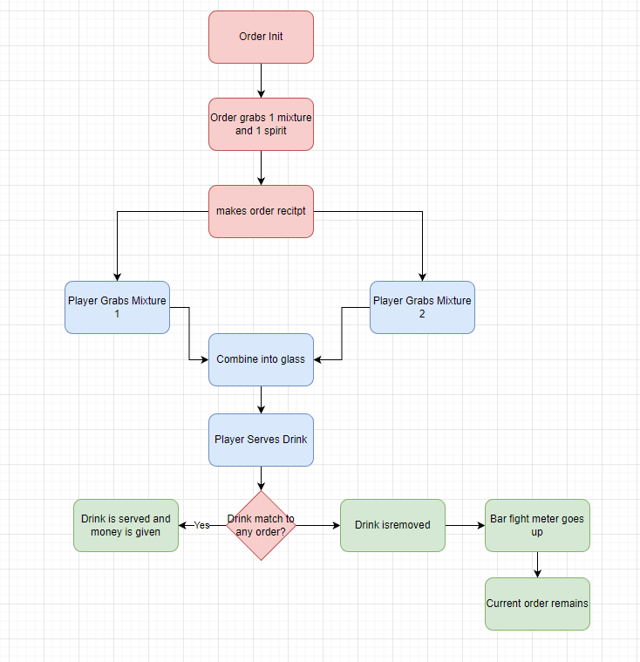
Figure 6 - Cocktail Mixture System
The player will have to interact with the housing workstation for each of the mixtures to.
Identify – pick up – mix – put back. After doing this twice (mixture 1 and 2), the combination will be complete, and the player can hand over the cocktail at the serving station. If the order exists, the current drink is removed along with its order and money is given. If the order is wrong and the player hands over the cocktail at the serve station, the bar fight meter is increased by x (30) and not money is given to player, the drink is also destroyed, and players would have to start again.

Game Pillars

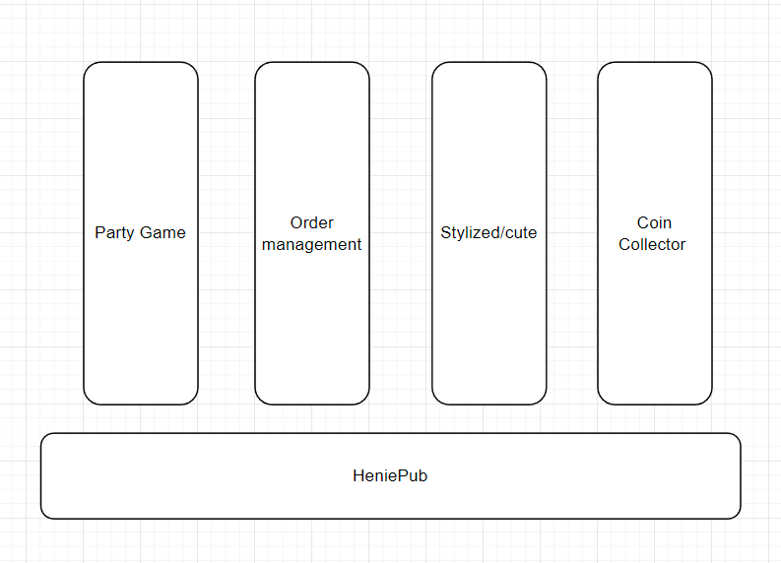
Figure 7 - Game Pillars

Pickups
The level will have different objects and wall that the player can interact with for needs. Such objects are:
- Counters – can place and pick up object from
- Beer/Drink Pouring Station – Pours the drink into the cup the player is holding.
- Glass Holder – where the player can get clean glasses from
- Serving Area? – where the player will deliver the drink too?
- Beer Barrel – The barrel that will hold beer and need replacing when empty.
- Decorative Wall – a blocking wall that player cannot interact with and is used to take up room.
The player can interact with most of the objects in the room, that will have a unique function to them.

MoSCoW

Must
- Complete game loop that includes.
  - Order system
  - Counters for player to place objects on
  - Pouring system for players to be able to pour drinks into glasses.
  - Serving system to hand over good and receive reward.
  - Money counter to track coins.
  - At least 1 drink that they player can serve.
- Bar fight system
- Score system
- 2 levels
- 2 Player/Coop ability

Should
- Different drinks to serve for more difficulty.
- Mini games for player to do and add to difficulty.
  - Changing the barrel on serving station
  - (Can include spill system on here)
  - Player must move slider into right areas to pour best pint.

Could
- Upgrade system that allows the player to choose different upgrade to help around the bar.
- Spillage system
  - Player can drop or overfill drinks causing spillage, requiring a clean-up.
- Different drinks to serve for more difficulty.
- Cocktail Making system (Combination mechanic)

Would
- Roaming Ai

Level Design Plans

Level Rules
- The level will be sectioned into an equal grid of squares for which objects can be placed upon. Each square will represent an object that the player could interact with.
- This means levels can be module and built quickly as the rules for making the level will be (object must fit onto interlocking square).
  - Therefore, Assets made need to be 100x100 to fit together when being built. (Though this is to be finalised).
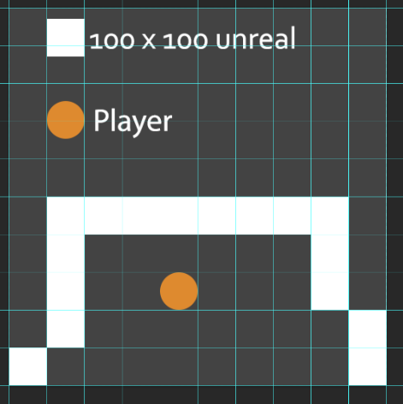
Figure 8 - Level Size

Level Plans

Maps
Sample Design Layouts
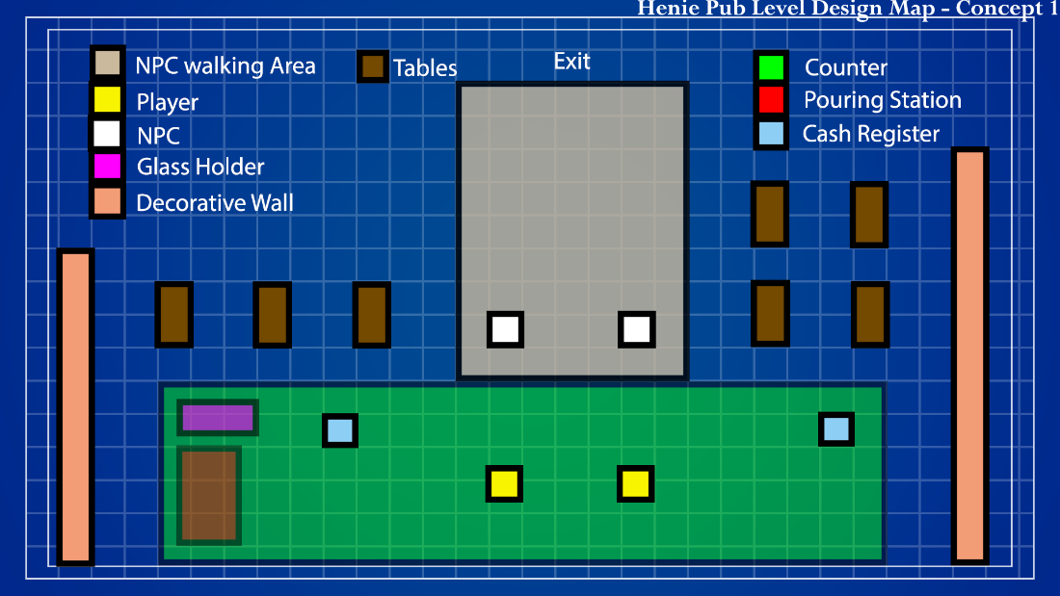
Figure 9 - Level layout design 1
1
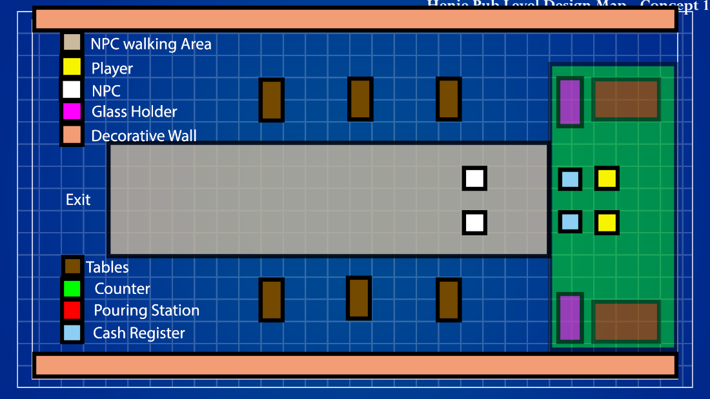
Figure 10 - Level Layout Design 2

Tutorial Level
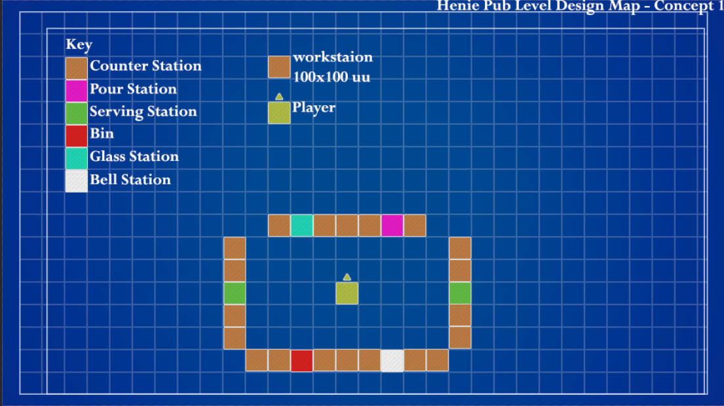
Figure 11 - Tutorial Level Design Layout

After Hours Level
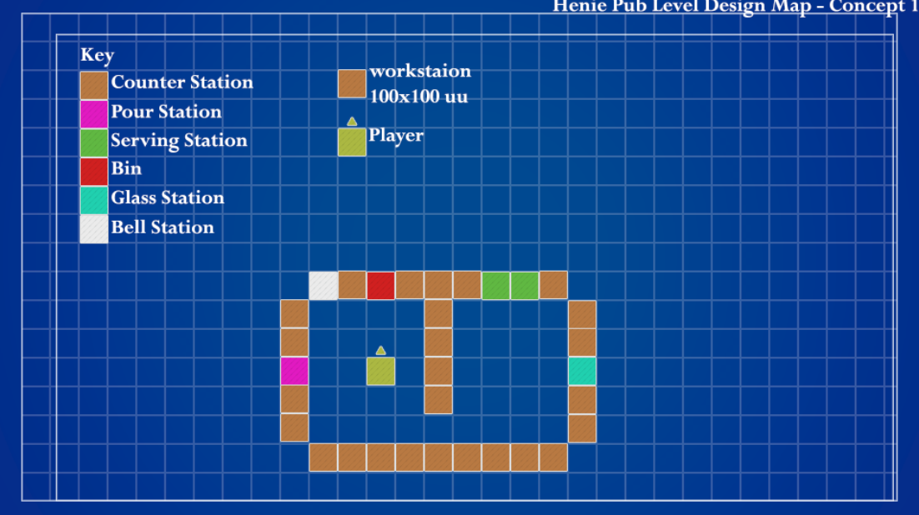
Figure 12 - After Hours Design Level Layout

Wheel Level

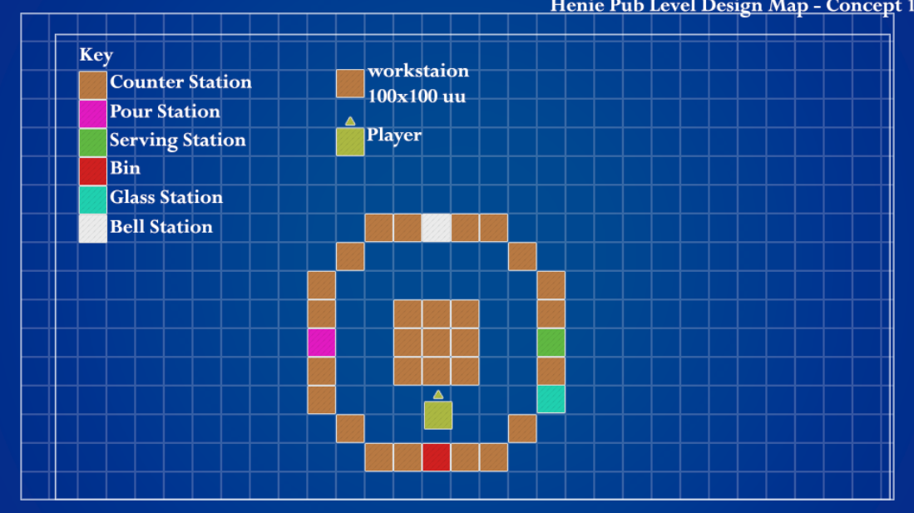
Figure 13 - Wheel Design Level Layout

Player Character, Controls and Abilities

Control Maps
- The character has basic movement controls.
  - ‘WASD’ – move.
  - E – Interact
  - ESC – Pause Menu

Level Camera(s)
The camera will be fixed in place above the player, keeping in view the bar/pub area. This will be the only camera throughout the playthrough.

Character Mechanics
- The character will have one main mechanic, that’ll be the ability to interact with other objects.
- By pressing interact the player can utilize the ability to complete orders.
- Different machines require different inputs.
  - When the player is filling up a glass with beer, they must hold the interaction button. Upon release, the interaction is stopped and so it’s ‘event’.
    - The state of pouring and other activities will be indicated via a progress bar with different blocks on the bar representing the current progress.
  - Cleaning a spillage will require the player to walk over to the hazard and interact. Like pouring, the player will have to hold down the interaction button until the hazard in cleaned before letting go.

Character Stats
Movement Type | Amount
Walk | 600 current

UI

Ui Needs
- Main Menu
  - Single Play (lead onto level select)
  - Two Player Play
  - Options Screen
  - Credits
  - Exit
- Level Select Screen
  - Back Button (to main menu).
  - Level selects options with different levels.
- Gameplay
  - Pause/Exit Menu
    - Resume
    - Options
    - Exit
- UX – gameplay
  - Game Timer
  - Coin Counter
  - Control Map?
  - Progress Bar
  - Order System

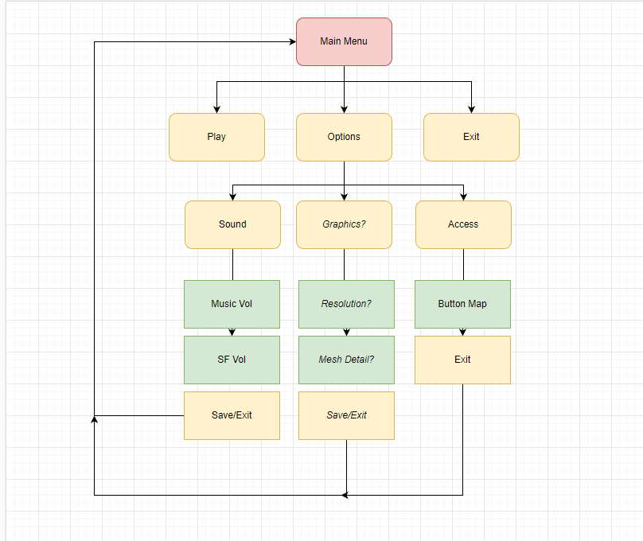
Figure 14 - Main Menu Design Flowchart
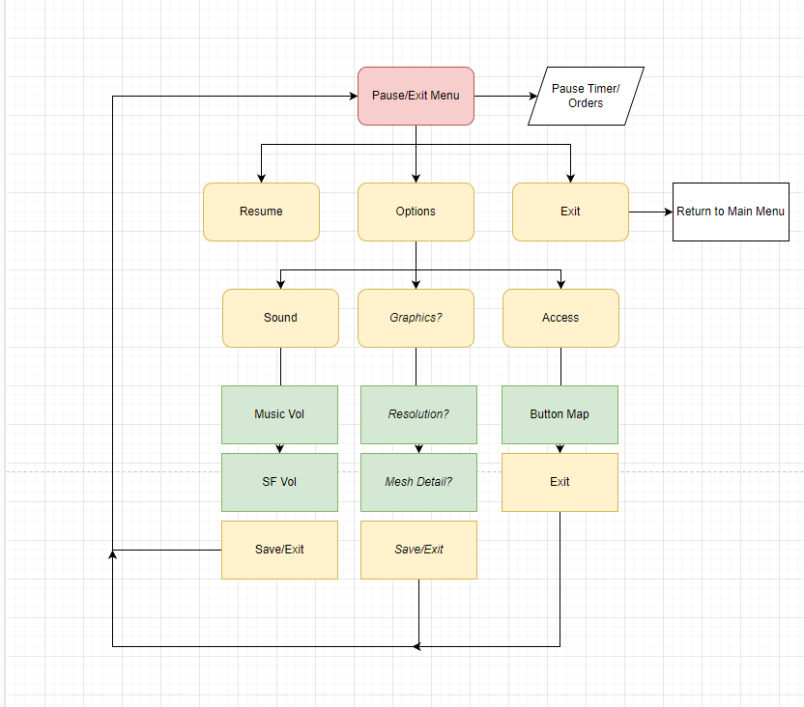
Figure 15 - Pause and Exit Menu Flowchart

UI Wireframes
Main Menu
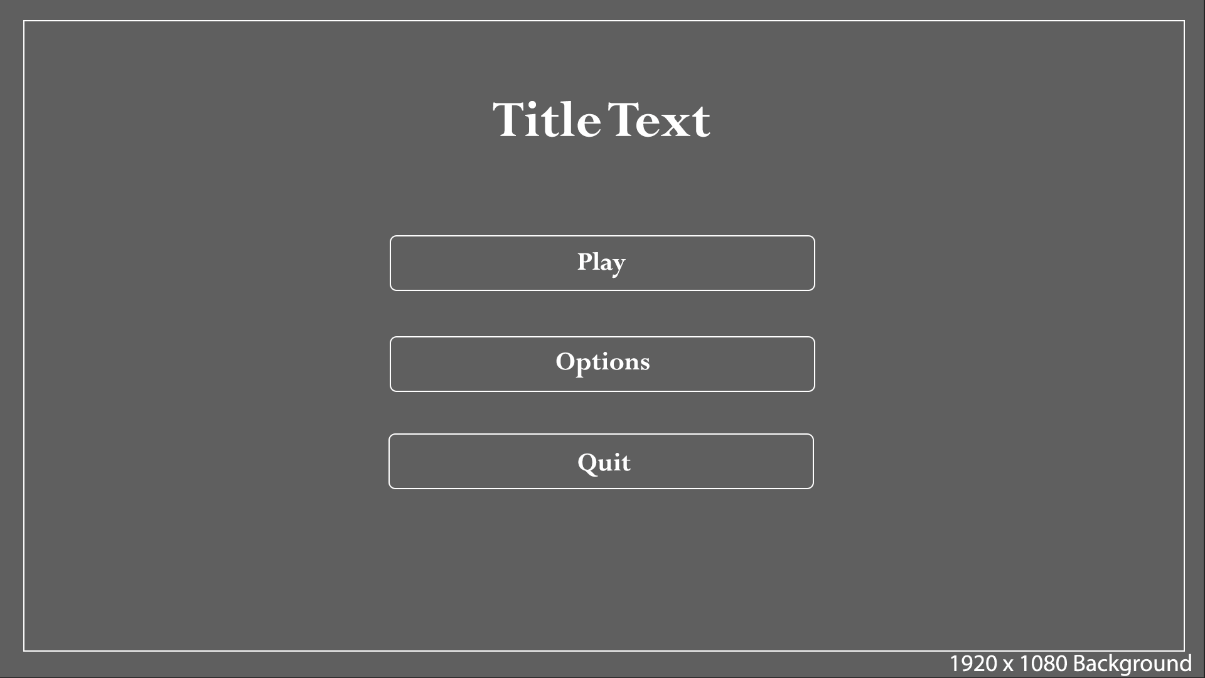
Figure 16 - Main Menu Design
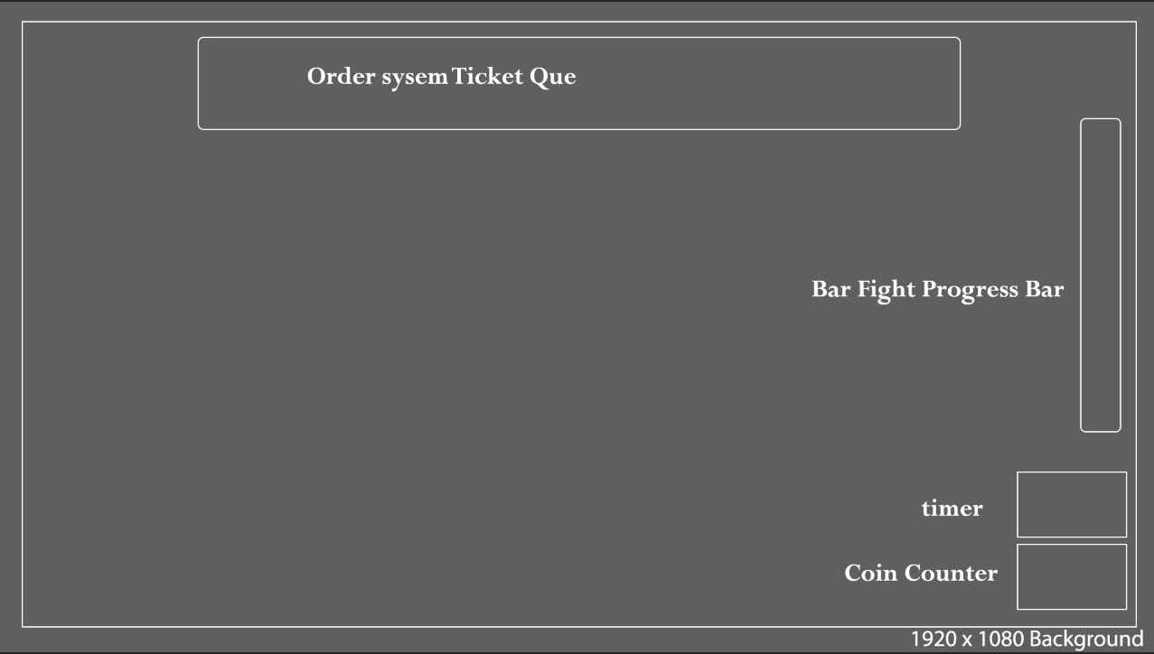
Figure 17 - Gameplay UI Design
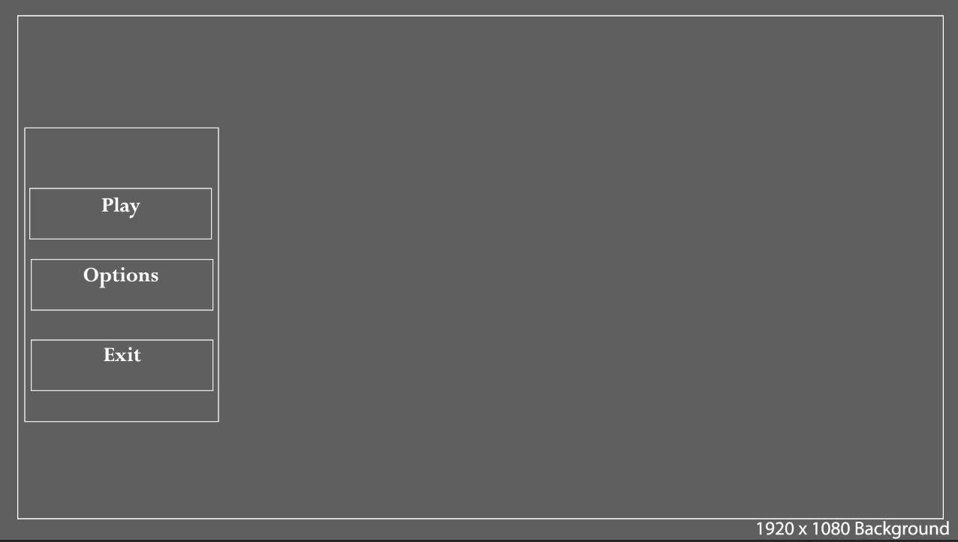
Figure 18 - Pause Menu Design

UI Sounds and Text
A list of sounds and text styles we could possibly use for the collab.

Text Styles
- https://fontmeme.com/fonts/lapsus-pro-font/
- https://fontmeme.com/fonts/maybe-coffee-font/
- https://fontmeme.com/fonts/want-coffee-font/
- https://fontmeme.com/fonts/lemon-days-font/

Sounds
Are allowed to use asset packs with sound.
Freesounds.org another good source for sounds.
- Background music during gameplay
- Ui button clicks.
- Menu music
- Interact action sounds.
  - Placing object on/off counter.
  - Pouring Drink.
  - Getting a glass out of case.
  - Footstep sounds.
  - Complete order sound.
  - Coin received sound.
  - Bar fight sound/music

Bar fight sound/ music – similar to sabotage sound in among us.

Game Conditions

How do you win?
- The players overall goal is to generate the highest overall score.
- Score is determined by how much money they have collected by the end of a run. The more money == higher score.
- Money can be gained and lost in different ways, and this affects the player score.
  - Money can be gained by completing customer orders in time.
    - Additionally altered by how ‘good’ the drink pour is.
    - Time remaining on a customer order.

How do you lose?
End Game
- The player can lose in different ways.
  - By getting 3 strikes and causing the pub to fail (not completing 3 orders in time)
  - Not stopping a bar fight.
  - Negative reviews- Bad pours can lead to getting negative reviews depending on the mood of the customer, receiving 10 negative reviews ends the game.
  - Not being able to refill the barrels.
- Upon losing, the final amount of money will be calculated into a score.
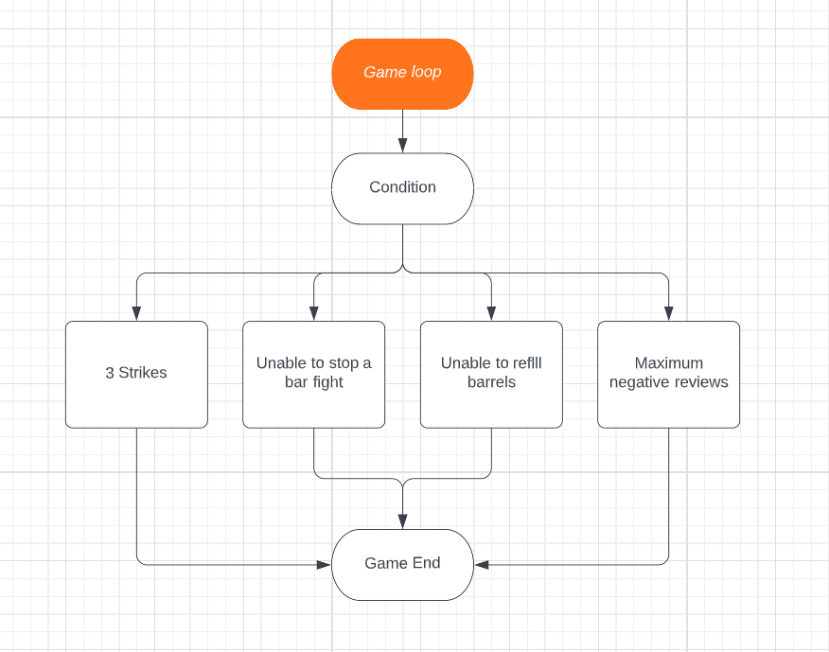
Figure 19 - Game Loop Concept

Reward and Progression

Game Progression

- Rewards/Progression:
- As the game goes on, the player will unlock new kinds of drinks to serve. Some of the drinks will require new ways of interactions to complete, while others require similar ways.
- The idea is the player will find it more challenging as time goes on to complete multiple different orders in different ways.

- Rewards and coin balancing
- As the game progresses, more and more orders will come in for the player to serve. This will make the game gradually difficult overtime.
- The longer the player keeps the bar going and drinks are served, the more coins they get adding to the total high score at the end.
- If a pint is bad, good or perfect-
- Bad- the customer leaves a negative review, which is -5 coins and 1/10 negative reviews on the board.
- Good- the customer appreciates it and hands in a random tip (0.5-1 coin).
- Perfect- the customer leaves a positive review, which is +3 coins and 1/10 added reputation, 10/10 added reputations reduces one negative review.
- The main timer is divided into 4 parts, depending on which part the player lands in during the pour, they will be rewarded with coins pertaining to that part of the bar.
- For the first part (0-25%), player will be awarded 1 coin.
- Second part (25-50%), 2 coins.
- Third part (50-75%), 3 coins.
- Fourth part (75-100%), 4 coins for each pour.
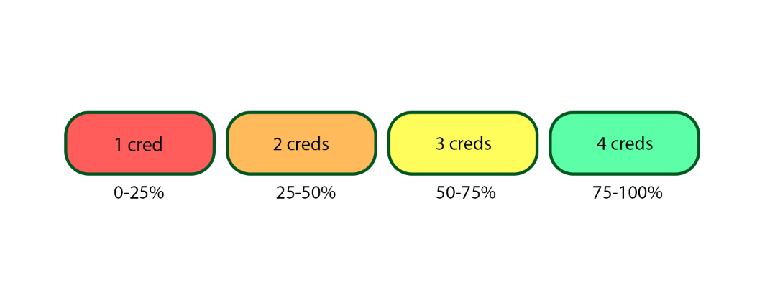
Figure 20 - Redacted Card System
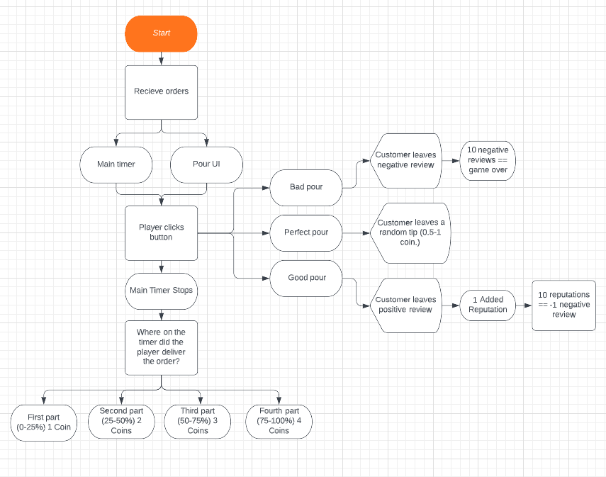
Figure 21 - Game Loop Concept 2

Player Goals
The players main goal during gameplay will be to serve as many drinks as possible in time without failing to either:
- Stop a bar fight.
- serve 3 drink orders.
The overall end objective will be to rack up as much money (coins) as possible to then get the best high score.

Figure List
Figure 1 - barrel pour amount 5
Figure 2 - Barrel Concept 5
Figure 3 - Bar Fight Flowchart Layout 7
Figure 4 - Order Card Concept 8
Figure 5 - Pour Pint System Flowchart 9
Figure 6 - Cocktail Mixture System 10
Figure 7 - Game Pillars 11
Figure 8 - Level Size 13
Figure 9 - Level layout design 1 13
Figure 10 - Level Layout Design 2 14
Figure 11 - Tutorial Level Design Layout 14
Figure 12 - After Hours Design Level Layout 15
Figure 13 - Wheel Design Level Layout 15
Figure 14 - Main Menu Design Flowchart 17
Figure 15 - Pause and Exit Menu Flowchart 18
Figure 16 - Main Menu Design 18
Figure 17 - Gameplay UI Design 19
Figure 18 - Pause Menu Design 19
Figure 19 - Game Loop Concept 21
Figure 20 - Redacted Card System 22
Figure 21 - Game Loop Concept 2 23

