Game Design Document

Ebonwald

Daniel Brooks

Contents
High Concept
Level Design Documentation
Level Design Plans
Player Character
Conditions
Cinematics and cameras
UI

High Concept
Overview:
Ebonwald is a 3rd person RPG game where the goal of the game is to explore the level the vast beauty of the landscape, I will create focusing on both level design and environment design. The player will be able to traverse from one point to another whist indulging themselves with the world I will make.
The player will control a character who will be an old soldier, using either mouse and keyboard or controller. With the goal on exploration of the world.
The level itself will feature multiple POI’s (points of interests) that will include a little setup scene followed with a camera sequence. In addition to this the level will include a town that the player can go up to and walk around, talk, and see locals there then leave.
Ebonwald takes inspiration for games like Skyrim, Zelda BOTW and Witcher.

Story – not final
You (the player) find yourself lost in the world of ‘Ebonwald’. Looking to reach your home you need to traverse the land to get back. Explore, find new and interesting things along the way as you find your place in the world

AI
There will be AI involved in my game however, rather than have enemy AI Ebonwald will consist of friendly AI that the player can interact with, talk, and ask question about the world and or the current situation. The main reason AI will be involved in the game is to help the player explore the world as well as be a helping hand guiding the player to an area that the player might not necessarily explore or know about.
An example of this would be the player interacts with a villager and the villager tells them of a ‘mysterious glow in the forest to the east’. The player now will note this and might go explore the occurrence.

Theme/Setting:
Set in a fantasy/medieval era taking the aesthetic look from medieval German and Scandinavia. The world in which the player finds them self in is a grassland esc looking plain with, trees, hills, mountains, forests as well as human villages and towns.
The theme will be realistic/fantasy utilizing the UE4 marketplace for assets to use. As mentioned before, Ebonwald will be more of a realistic looking game using real life geography to make things seem more ‘real’.
The megascan library will be a good helping for this as getting realistic looking props in quick and freely will help for both blockouts and meshing.

USP:
The main selling point for my game will be its large landscapes and vast, beautiful terrain for the player to explore around.
I want to make a game that looks visually stunning to the player with big open landscapes and vast areas to explore as well as interactable things make the player feel like they are there controlling themselves doing what they would do. Hopefully, this will be enough to keep player interested and busy in my game.

Target Audience
Target audience for my game will be around the 12+ age group and for people who enjoy most RPG and storytelling games. My game really isn’t one where you can afford quick 5-10 mins plays in-between breaks, its rather the opposite with target people who have the free time to play RPG games. The 12+ Range seems a good area to target because it allows for me to make the game with some form of difficultly rather having to give the player constant help if it was a game aimed for a lower age group.

Asset List
Customizable Grid - https://www.unrealengine.com/marketplace/en-US/product/customizable-grid
Kite Demo – Grass
Landscape - https://www.unrealengine.com/marketplace/en-US/product/brushify-forest-pack
Forests - https://www.unrealengine.com/marketplace/en-US/product/redwood-forest
Village pack - https://www.unrealengine.com/marketplace/en-US/product/medieval-village-megapack-with-interiors
Environment pack - https://www.unrealengine.com/marketplace/en-US/product/meadow-environment-set
3D Character - https://www.unrealengine.com/marketplace/en-US/product/light-lamellar-armour-pack
Megascans - https://quixel.com/?utm_source=google&utm_medium=cpc&utm_content=megascans%20exact%20responsive%20search&utm_campaign=search%20brand
Movement -

Level Design Maps

Overview Map:
Below are some ‘overarching’ maps that show and represent the world I plan on creating. Whilst the map itself is very large, I will be focusing one a smaller part of the world and bring that bit to life. Here are some large-scale maps I drew detailing the world itself.
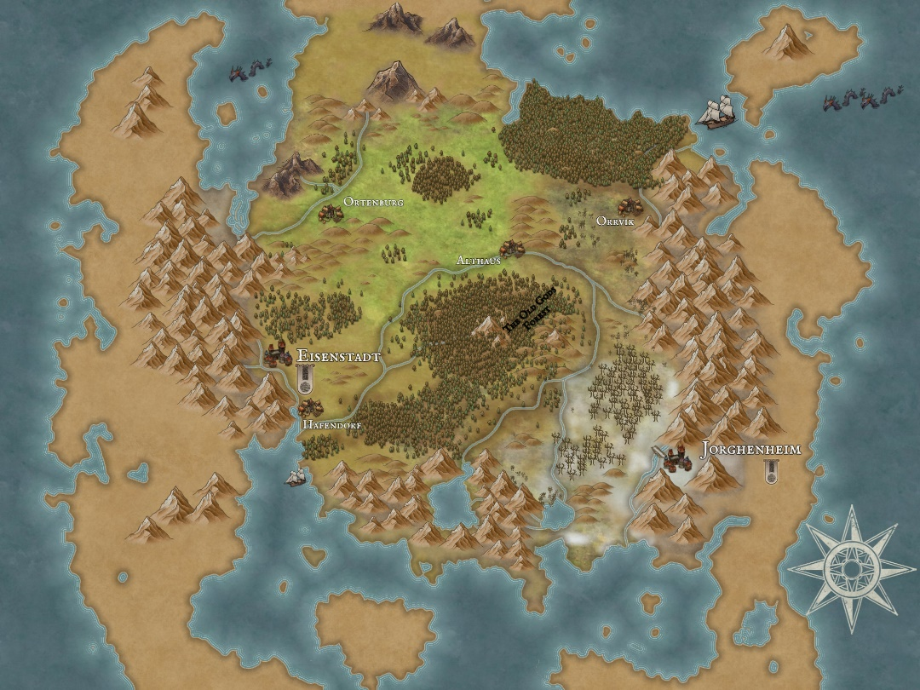

Overview Map

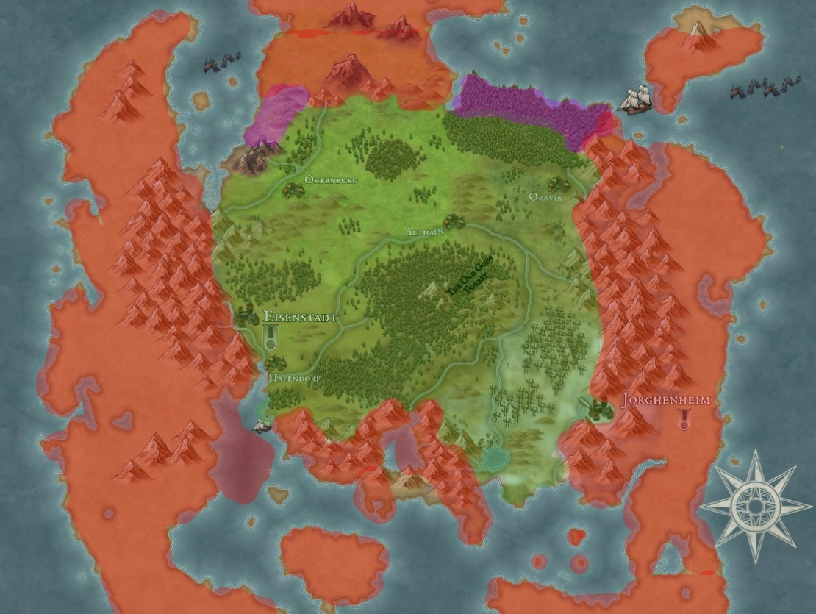

Player Space

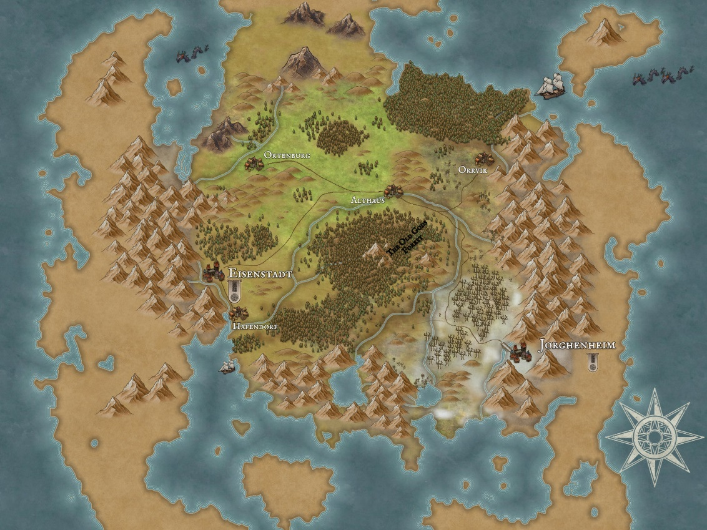
Player Path:

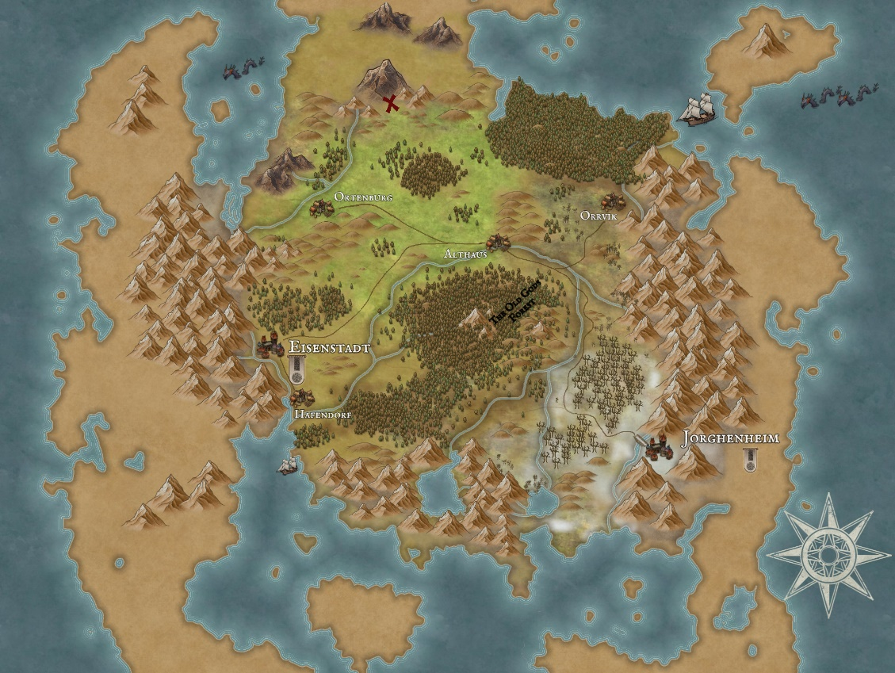
Player Start:

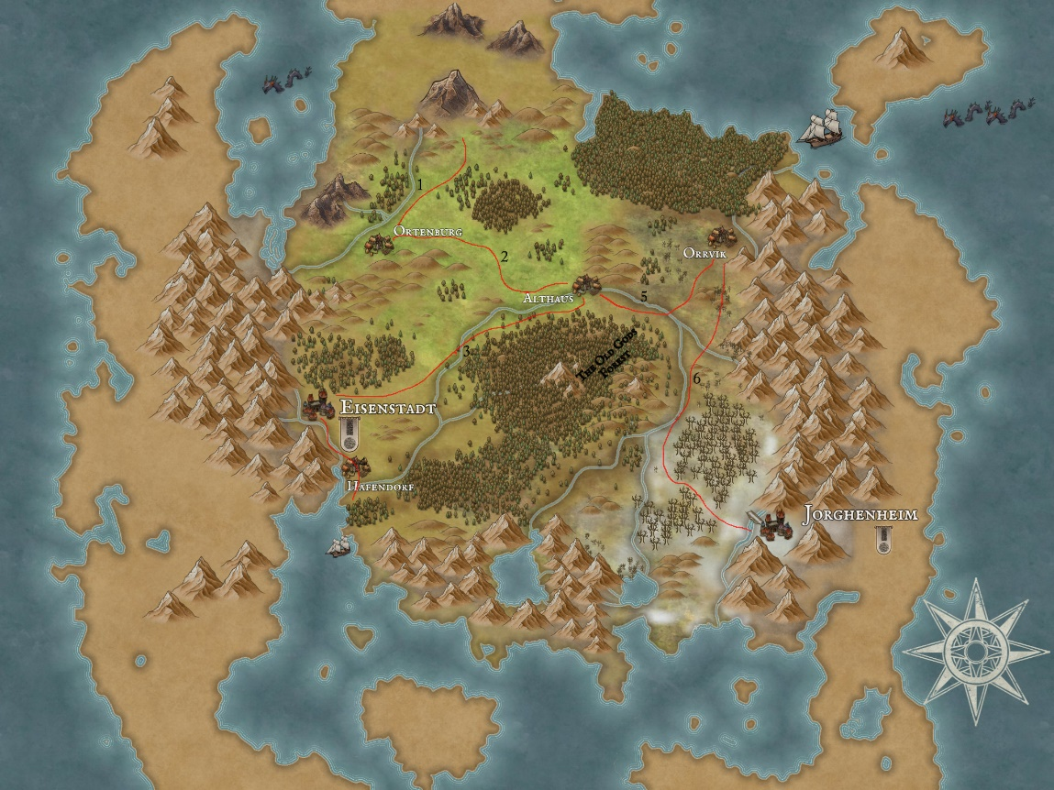
Critical Path:

Below are some of the more detailed maps that show the certain areas of the world. These include the POI’s, village, and other points.

Pencil Drawings:
New Village
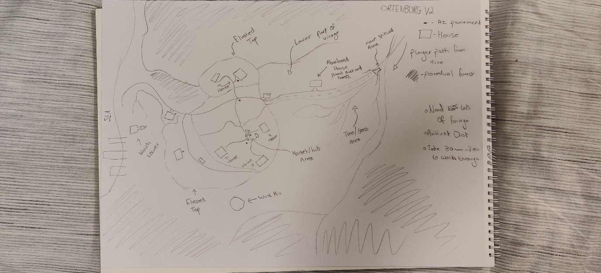

World Map
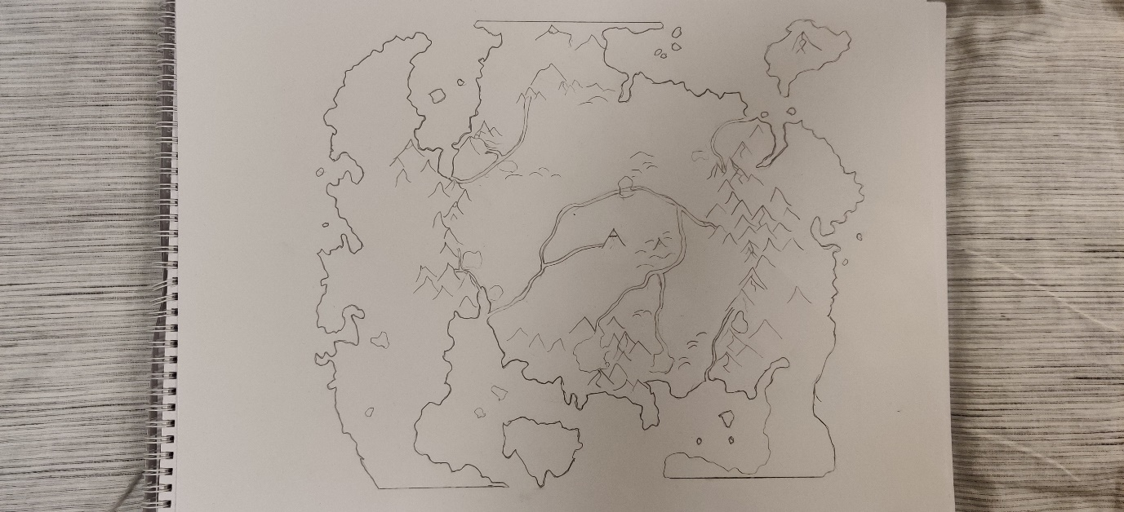

Hidden Camp
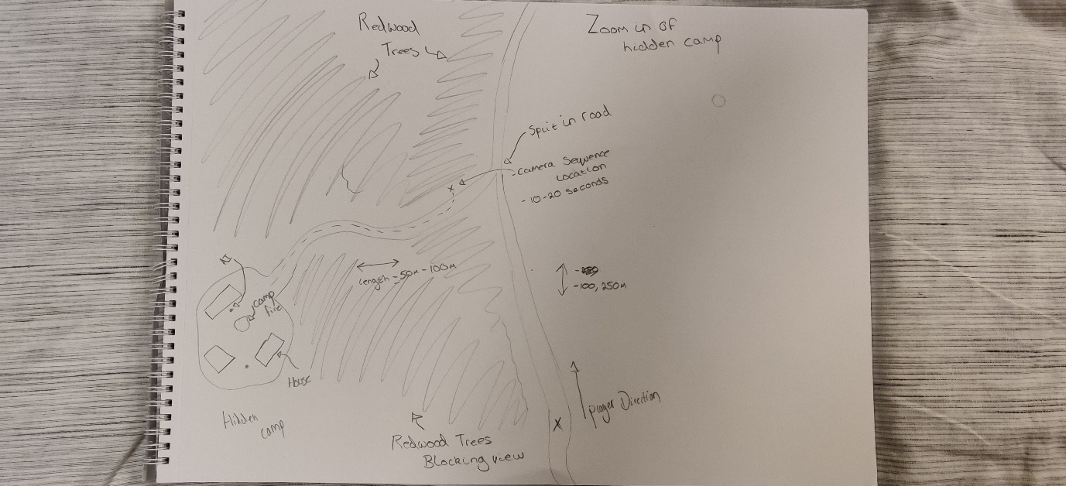

Old Village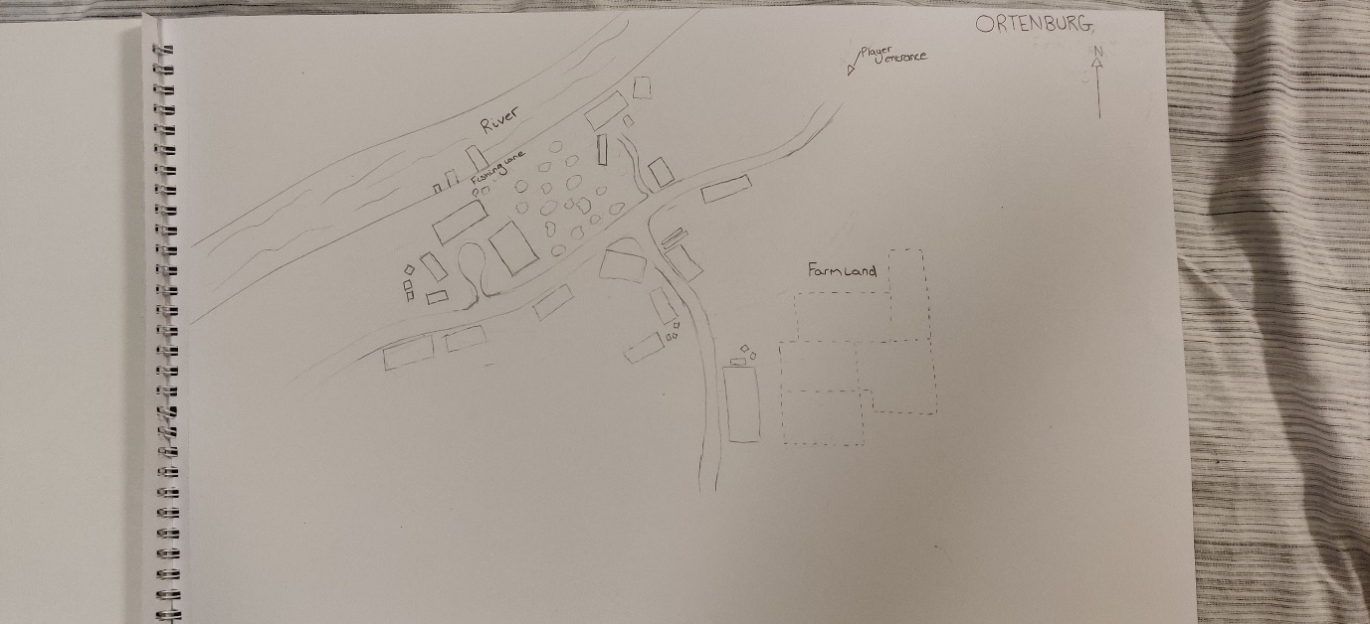
Starting Area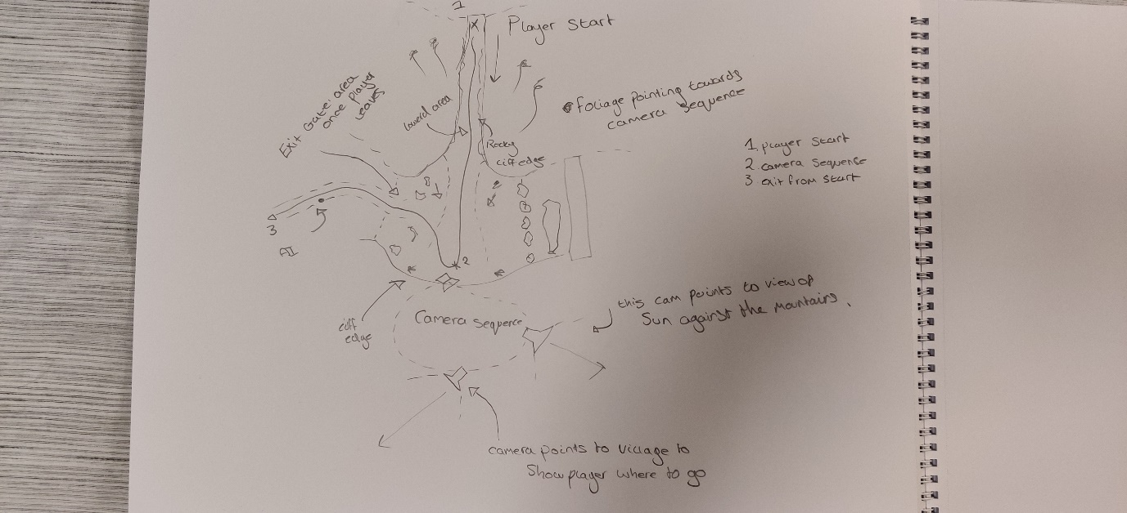

Old Village:

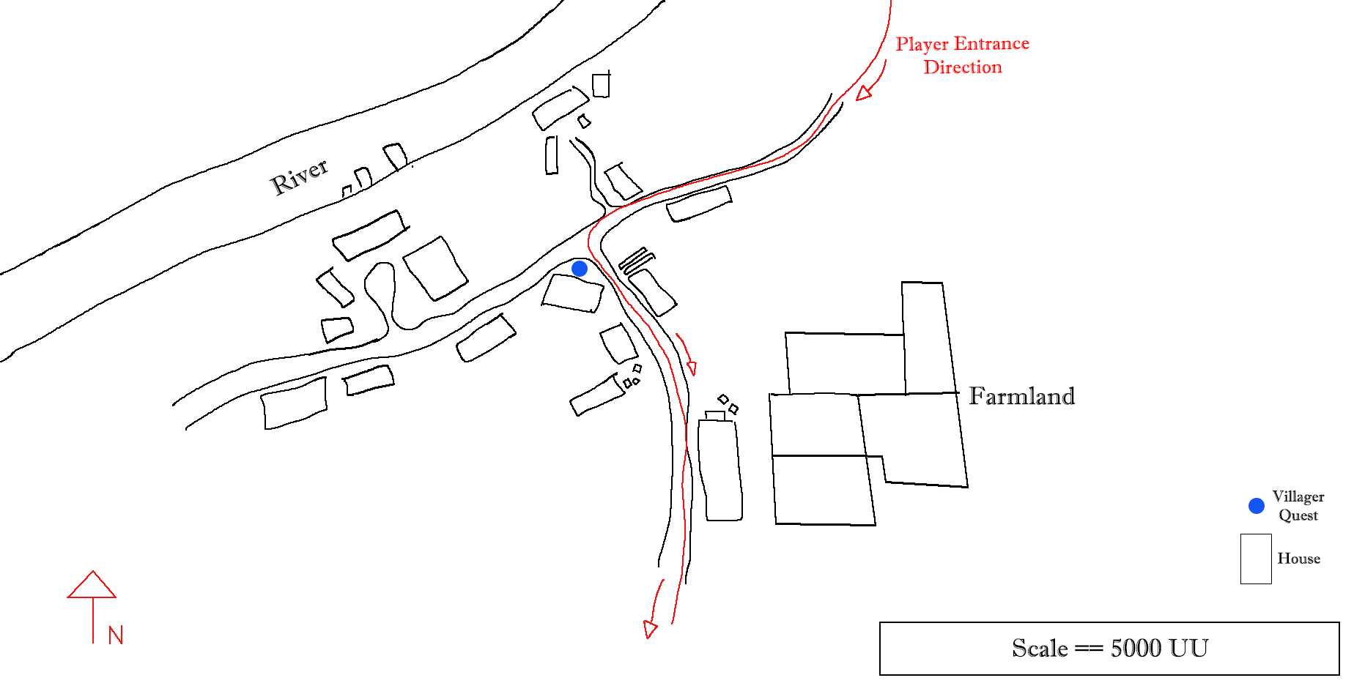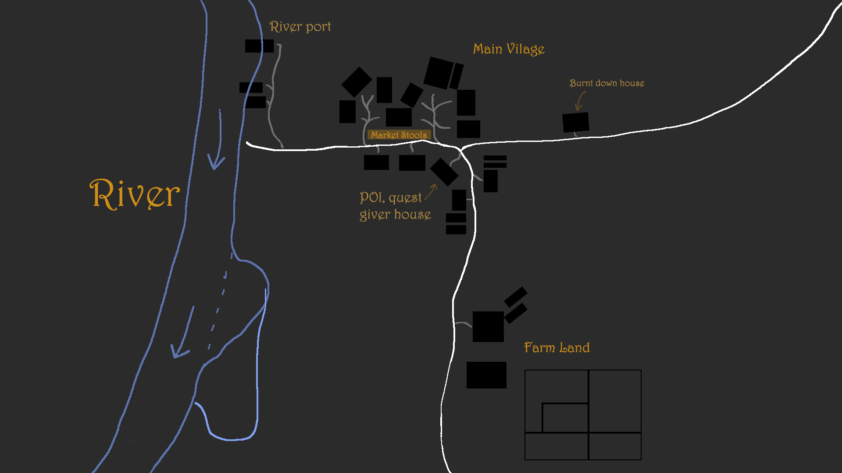

Final Layout Images
Below are the final maps that show the different areas of the level. This is what the player is going to be able to see, walk up to and explore.
Player route of the world:
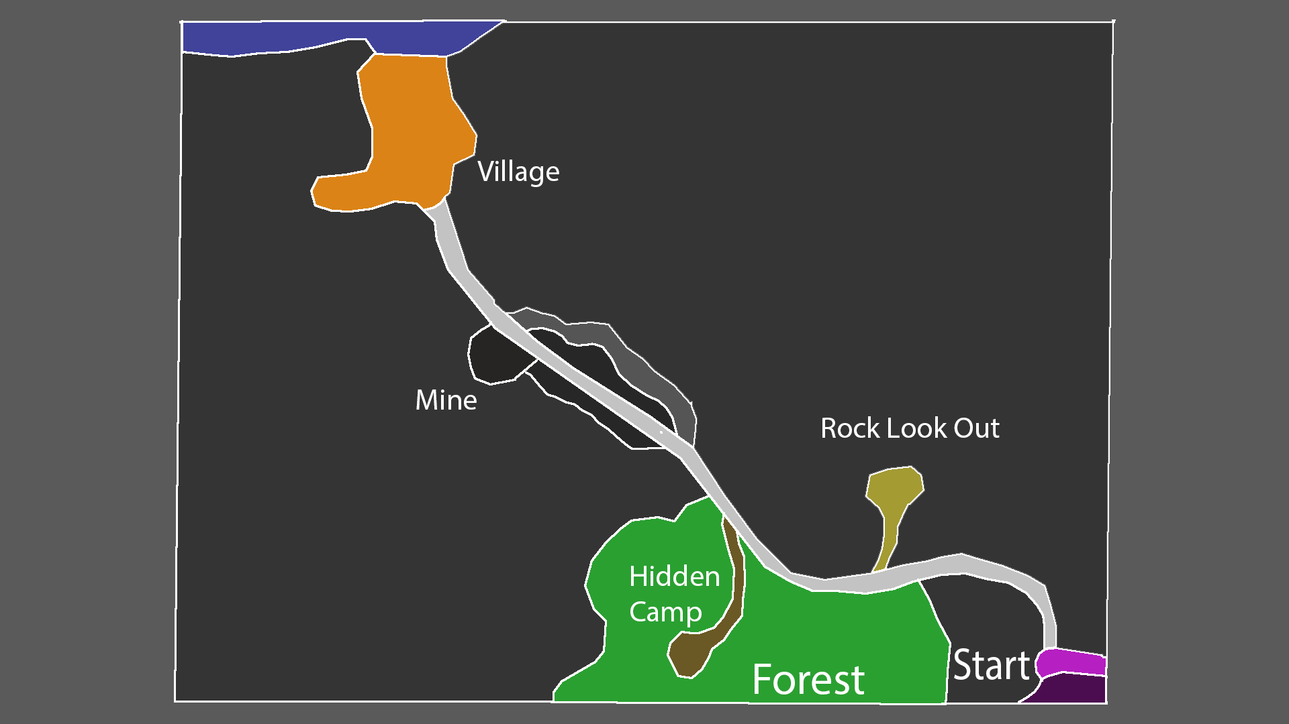
Hidden camp POI
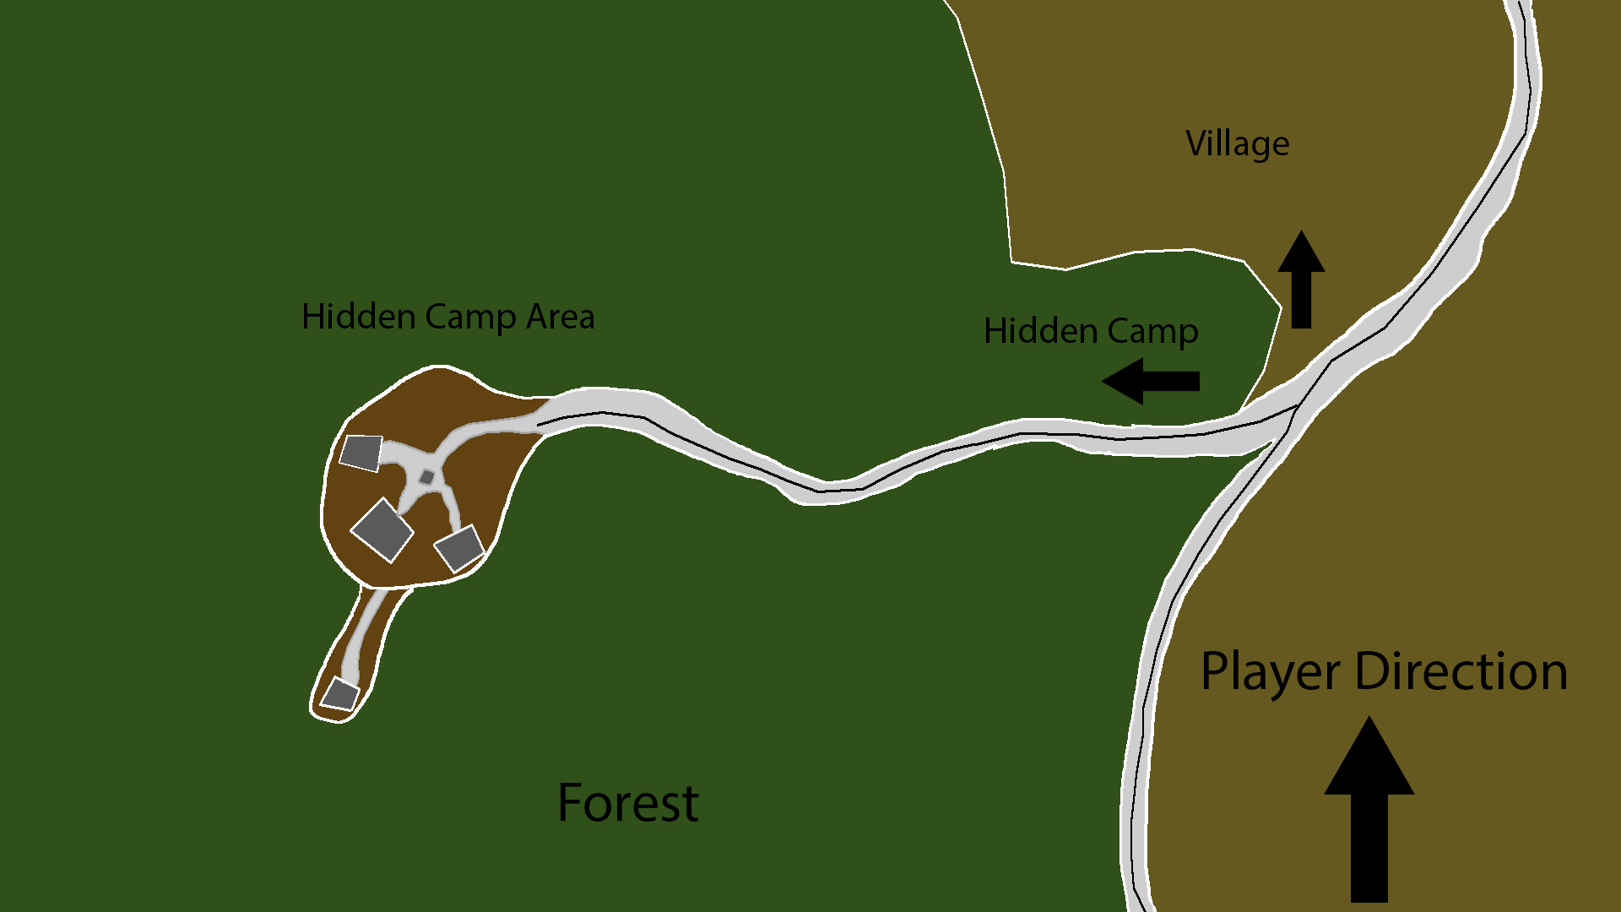

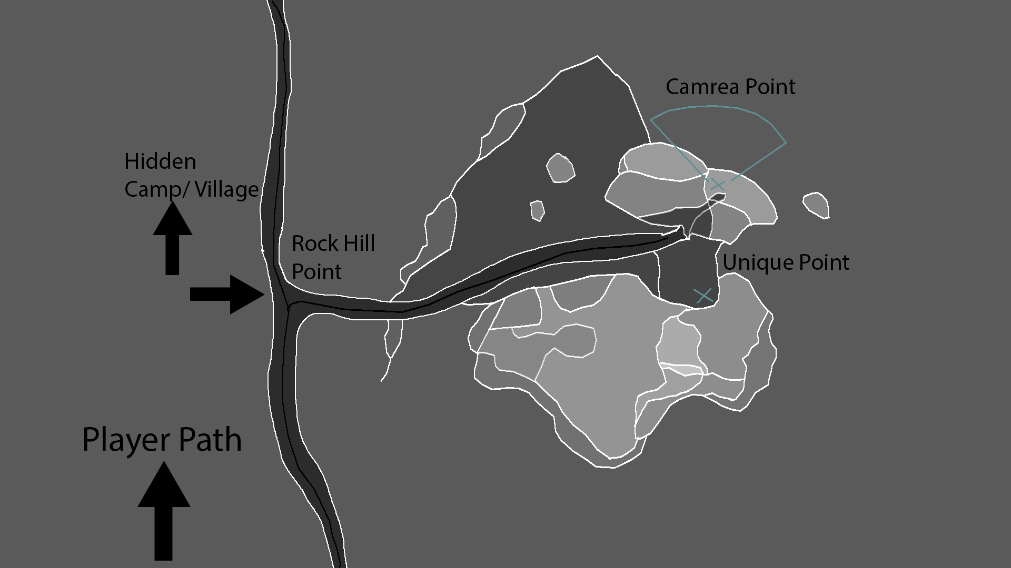
Hidden Camp POI

Mine area POI
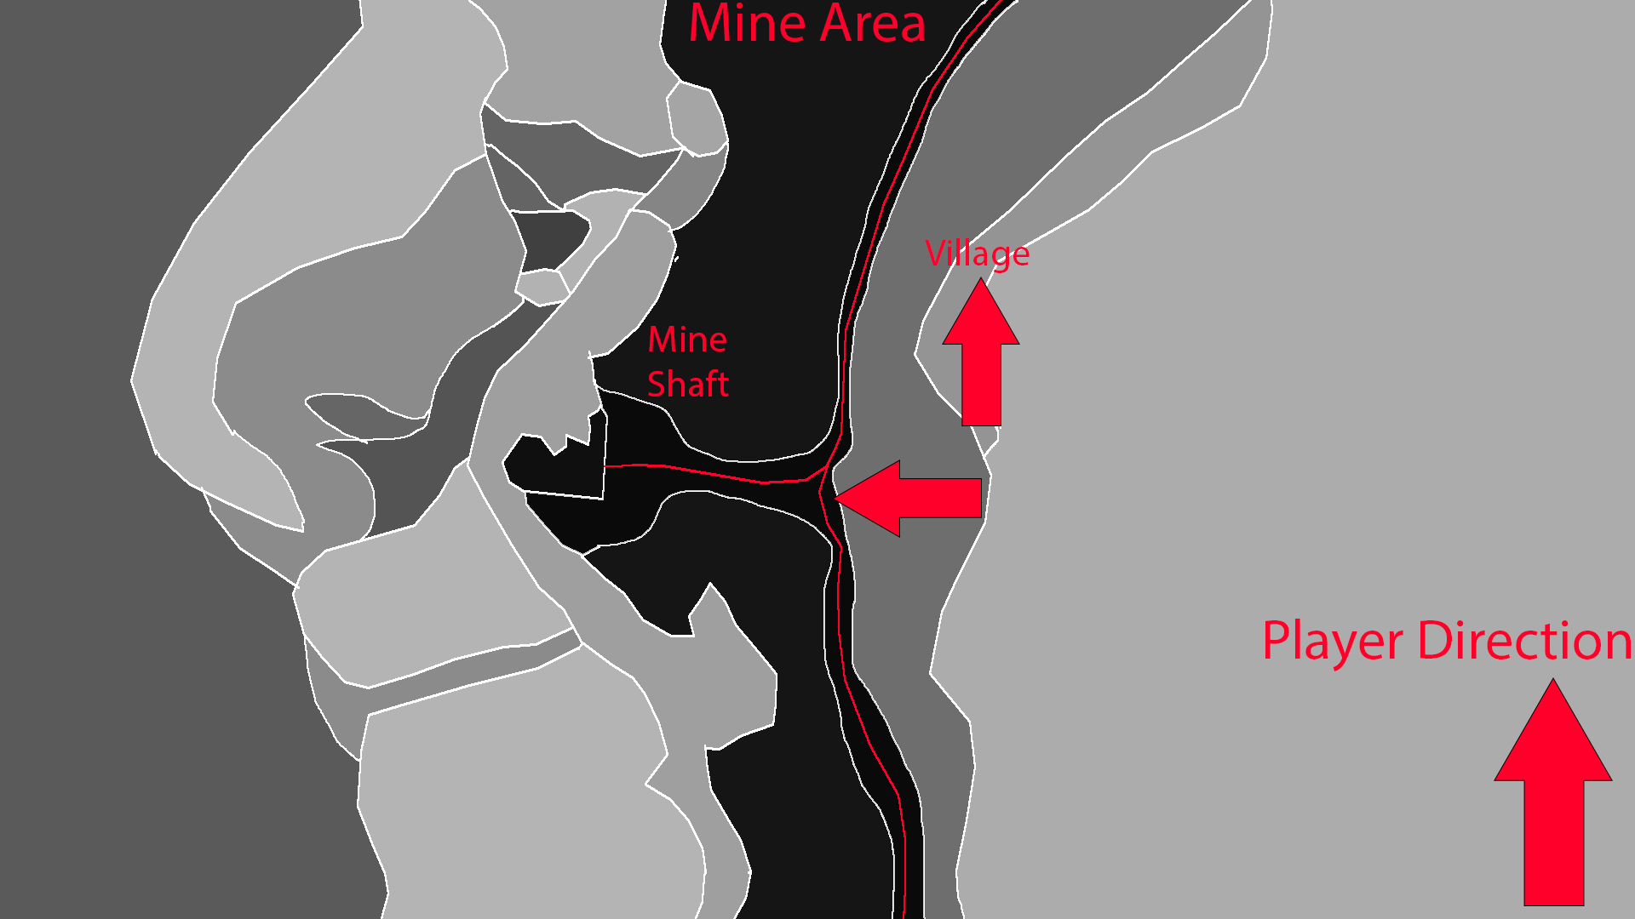

Village
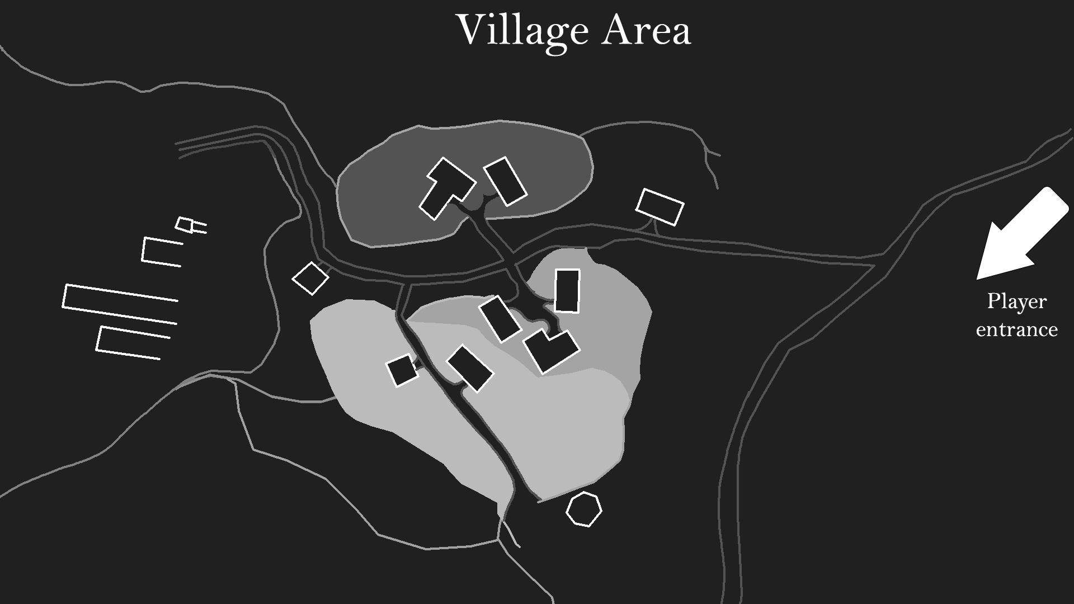

Beat Map
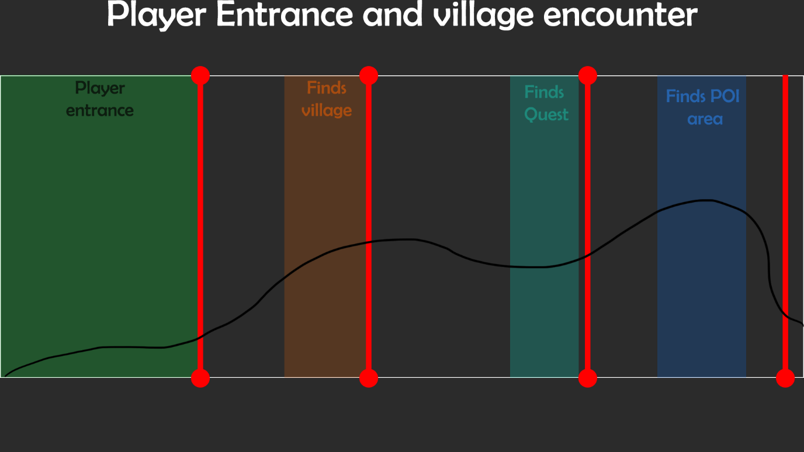
Map break down:
- The player will first enter the map from a hill overlooking the current level with the village in the distance.
- The player will work their way down to the village exploring the area as they go along.
- Once at the village, the player can interact with different NPC’s and eventually find a ‘quest’ for them to explore a certain area.
- They player will proceed to explore the area shown and find the POI.

Flow Diagram:
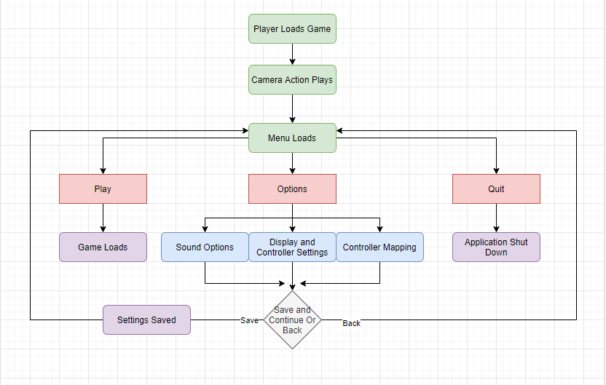
Flowchart shows how I want the process to work when loading up the game. The process should be quite easy to follow with the only complex one being options at this point, however there is also in game and other menus to look at.
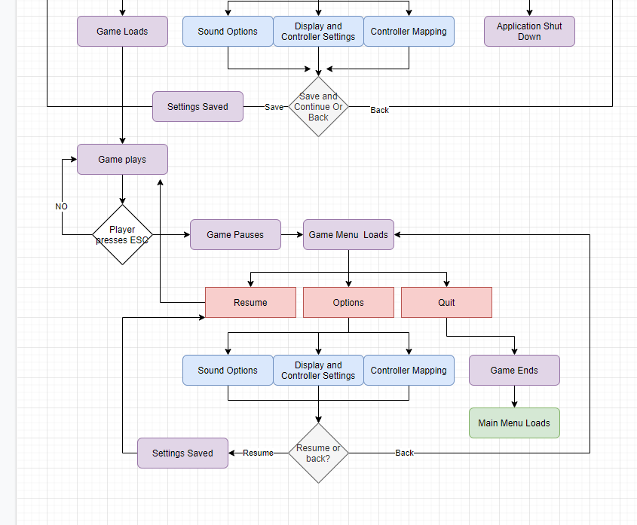
Here is the game play menu and how it will work, quite like the main menu above but with an incorporated resume button to take you back into gameplay. The quit side will take you back to the main menu and resume will take you back into gameplay from where u last paused.

Level Doc
Level plans:
The goal of my level is to show my environment building skills and level design. Therefore, my level doc and game itself will be tailored to this.
Level Breakdown:
At the start of the game, the player will be loaded onto a ‘cliff’ high up on a mountain. The player will be funneled down to a camera sequence using sound and the foliage as a helper. The way I plan to do this is by moving foliage is such a way it looks like the trees are pointing the player where to go. When the player hits the camera sequence it will do a ‘360’ of its positions focusing on the village showing the player where they should go. This will be something like the camera sequence from ‘BOTW’ at the start of that game. After this the player can leave the spawn and make their way down to the next ‘poi’
Finding the next POI will be simple to the player as I do not want it being to challenge. After a fork in the road the player can leave it and discover a secret graveyard which also as a camera sequence. This camera sequence will just feature a pan of the forest and the grave itself, alluding to what could be in the forest.
After that the player will encounter a ‘hidden camp’ within the redwood forest. This will be full of harmful AI wont might throw insults at the player to leave. Before this a camera sequences will player revealing the camp. The forest itself will be a lush, dense forest filled with big redwood tress and tropical bushes.
Next stop for the player will be the mine. The player will have the opportunity to look and explore the abandoned mine, no camera sequence will be present here as non is needed. The mine will be like the first POI to see, (as in its easy). Not much will happen here but the fact it will be dusty and Eire.
Finally, the player will make it to the town. The town will be where all the inhabitants live. The player can freely explore the town and see what going on. Some of the AI will be interactable and others will not. The town will feature a seaport as well as a little market area outside some of the houses where AI will be present... The town will be ‘hidden’ behind a forest/wood area full of life, where there will be lots of vegetation for the player to wander about around and see.
This will be the level I am going to create; I feel like it shows off the level details and world building skills I have to show off and it’s a project I am looking forward to making.

Player Mechanics

Controls maps:

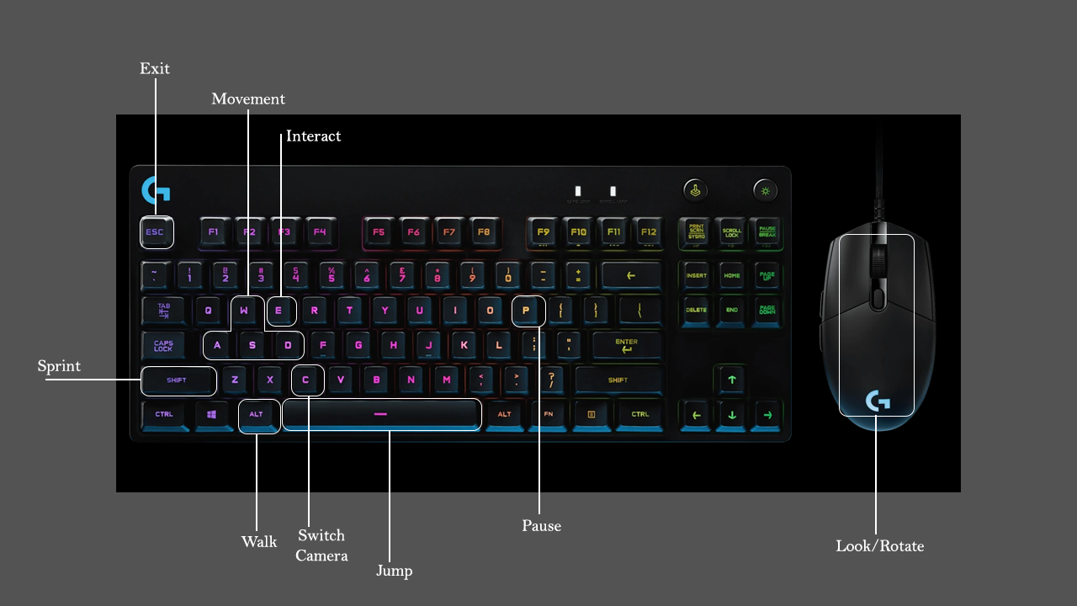
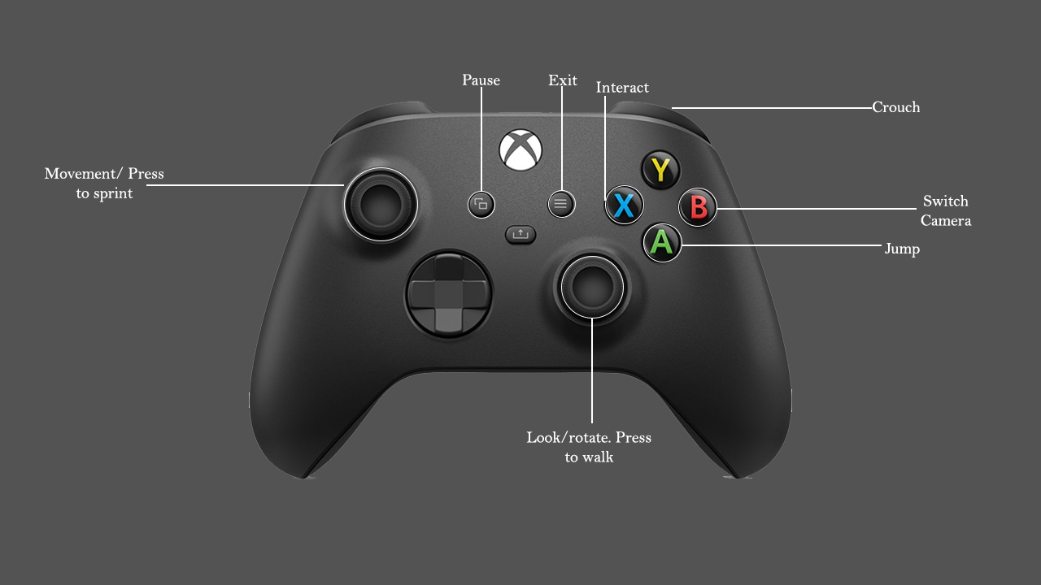

Camera:
Player:
Currently there are two styles of camera;
- The player camera will focus behind the player acting as a ‘Third Person Camera’. It will be able to spin around the player 360 degrees in all directions. This would be a more common style of approach to cameras for a third person game with it most likely being the most comfy and playable to players. Examples include Zelda BOTW, Skyrim and World of Warcraft.
- The second is a camera will be a first-person camera. This will be the default camera system as it gives the player the most emotions and indulgence int eh world compared to third person.
Menu:
The main menu will include a camera and render of 3D level rather than a black image. For this the camera will be placed on a crane and sweep reviling a landscape with life. The player character will be below this shot just in view with afterwards the main menu options kicking in. For this level it will include just one camera following a set path. The player character will be playing an idle animation at the bottom of the screen.
Level:
The main game/ level itself will include multiple cameras throughout. These cameras will be here to show cinematics and or different perspectives. Most of them will be set with trigger points that would then follow a path showing off the area. The plan is to have multiple POIS’s with cameras to show them off the three max. Additionally there might be cameras set up for villages that would trigger to show off a village before the player enters.
Movement and physics
Character | Movement Speed | Acceleration | Jump Speed | Gravity Scale | Can Run?
Third Person Example | 600 | 2048 | 600 | 1 | No
Advanced Locomotion | 600 | 1500 | 420 | 1 | Yes

Stats
The player won’t have any stats In the game as that isn’t the type of game I am going to be creating. I will be focusing on the map and level itself rather than player mechanics.

UI
Main Menu Screen
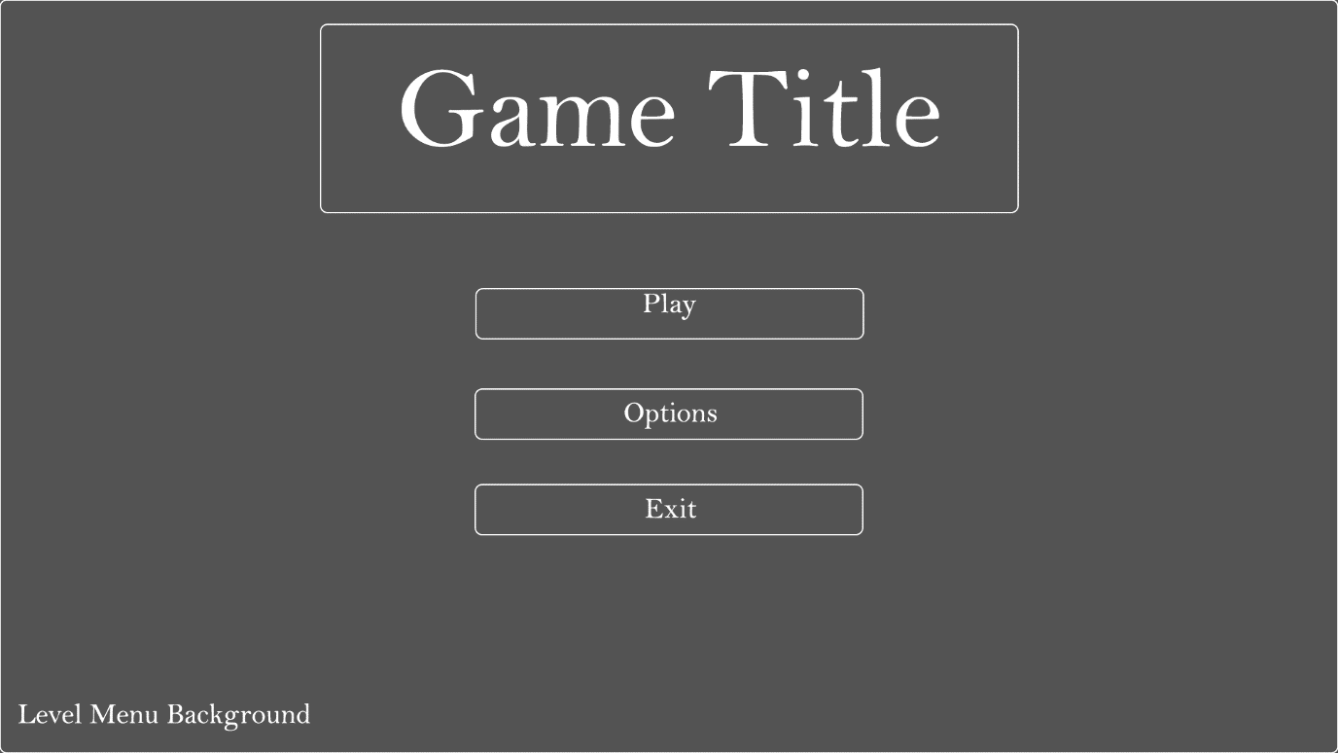
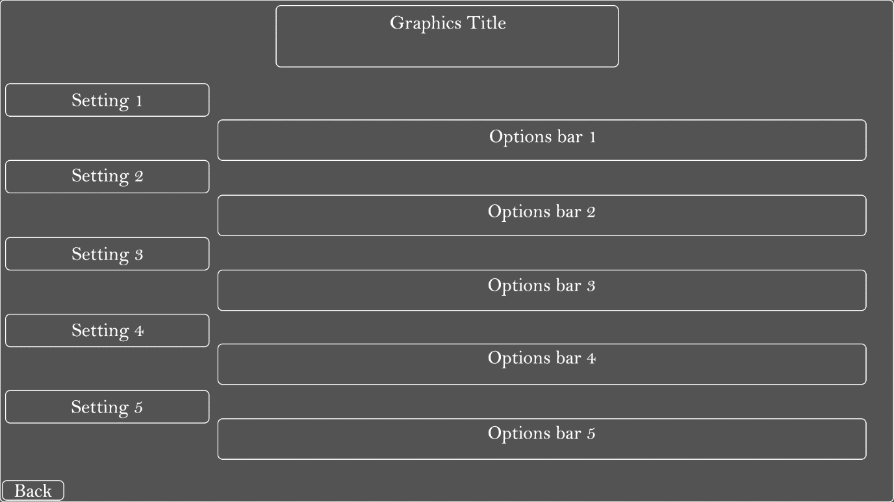
Graphics Screen Options

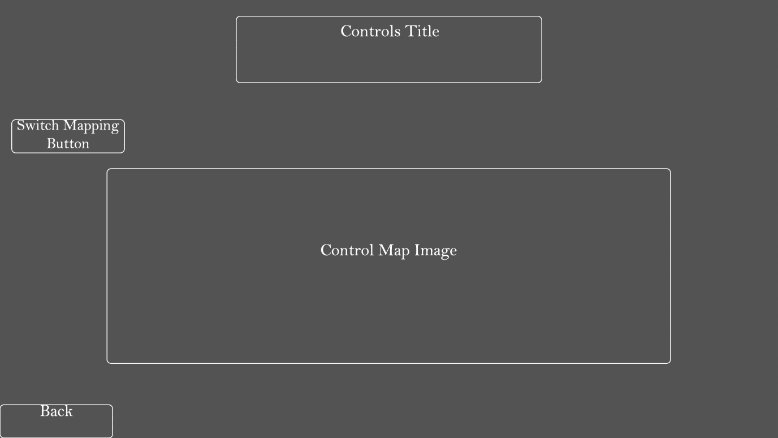
Control Options
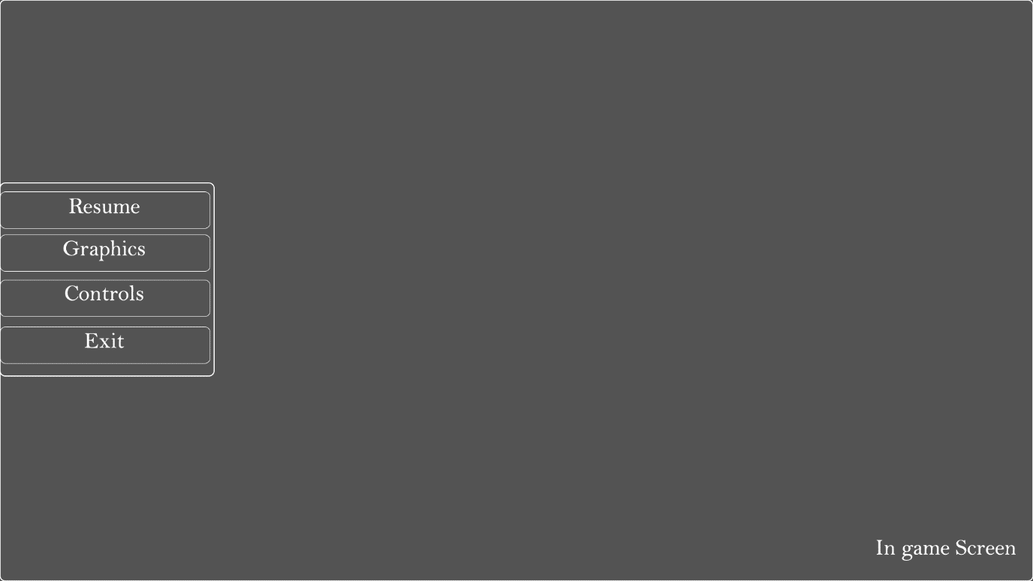
In game UI

Above are most of the UI designs that will require the most work and time on. Both the graphics screen and the Control screen will be usable for both in game and main menu UI to cut on work load for the UI. The UI will feature animations and sound to brings them a bit more to life rather than just being static images on the screen.

